**Staying tuned for the Book Fair in Warsaw.**

**The Book Fair in Warsaw will be held on May 26 – 29, 2022. The venue is *Plac Defilad* and the Palace of Culture and Science in Warsaw. We look forward to the biggest literary event of the year, hosting more than 500 exhibitors from 13 countries, including Poland, Norway and Ukraine, as well as Armenia, Belgium, Czechia, France, Germany, Hungary, Romania, Spain, Switzerland, and the UK. Visitors are invited to meet nearly 800 authors interviewed on several different stages, including 30 authors from Norway, which is this year’s Guest of Honour at the Fair. Admission to the Book Fair in Warsaw is free for all visitors, and some of the events will be broadcast on social media. The Book Fair in Warsaw is organized by the History and Culture Foundation.**

**Literary Norway**

As the Guest of Honour, Norway has a slogan reading *The Dream We Carry*. These words were written by Olav H. Hauge, a much-loved Norwegian poet, in his poem *It Is That Dream*. Readers will have an opportunity to meet many authors from Norway, including, *inter alia*: Jørn Lier Horst, Thomas Enger, Klara Hveberg, Victoria Kielland, Bjørn F. Rørvik, Per Dybvig, Erika Fatland, Torbjørn Færøvik, Nina F. Grünfeld, Kaja Nordengen, and Anne Sverdrup-Thygeson. Norwegian literary program spans fifty events designed to reflect the contemporary literary landscape of the country. During *The* *Children’s Hour* and *The Young Adults’ Hour*, visitors will meet some of the best authors and illustrators from Norway. During *The Green Hour*, they will be greeted by authors writing about nature, environment and travelling. In the series centred around *Domestic Dilemmas* they will get insights on Norwegian society and current issues through fiction; and in *The* *Mysteries of Man* and *The* *Crime Hour* they will also get a glimpse inside human mind. Norwegian literary programme will also revisit the past, with an introduction to Norway’s Nobel Prize winners and the history to World War II in Norway. Back into the present day, readers can enjoy the following themes: *The* *Poetry Hour*, including Ukrainian poetry; *European Feminists Anno 2022;* and *European Literature Today*. On top of that, there is   
a Norwegian trade program with a multitude of events for book professionals, with such themes as translation, literary policies in Norway and Poland, or library projects. Every hour, students of Norwegian language will offer a pop-up language course to give everyone a chance to learn the basics in fifteen minutes. Norway’s literary programme at the fair is organized by NORLA (Norwegian Literature Abroad) in close collaboration with the Royal Norwegian Embassy in Warsaw.

**Eye-to-eye with Ukrainian authors and publishers**

Another highlight on the agenda is the close up on Ukrainian literature. The History and Culture Foundation, the organizer of the Fair, has invited publishers and authors from Ukraine, offering this country its own stand and space in the programme in the spirit of solidarity with Ukraine. At the same time, in keeping with the memorandum signed by the Board of Directors of International Book Fairs, decision was made to refuse fair invitation to Russian publishers, who used to have their own stand in Warsaw. The joint stand of the Ukrainian Book Institute will promote the publishing offer of nearly 35 publishing houses and institutions. Readers are invited to meet some of the best known women authors from Ukraine, with Oksana Zabuzhko, who was asked to present a keynote speech at the opening ceremony, Viktoria Amelina, Tamara Duda, Lyubov Yakymchuk and Kateryna Kalytko. In cooperation with the Ukrainian Book Institute and the Embassy of Ukraine in Poland, books had been brought from Ukraine and will be available for sale at the Fair. The presence of Ukrainian publishers at the Book Fair in Warsaw will benefit from symbolic financial support mobilized by the Book Institute in Poland.

**Literary premieres, new releases, must-see events**

The Fair is a perfect place to meet your favourite authors, buy their books and get autographs. The opportunities will present themselves with literary premieres of such authors as Łukasz Orbitowski, Radek Rak, Wit Szostak, Mariusz Szczygieł, Victoria Kielland, Wojciech Chmielarz, Katarzyna Bonda, Vincent V. Severski, Maciej Siembieda, Magdalena Grzebałkowska and Ewa Winnicka, Katarzyna Tubylewicz, Magdalena Majcher, Lene Ask, Anja Dahle Øverbye and Adam Bodnar in conversation with Bartosz Bartosik, Urszula, Ullenka and Katarzyna Bareja. The Fair will also host Jakub Małecki, Anna Gacek, Marta Grzywacz, Konstanty Gebert, Krystyna Kurczab-Redlich in conversation about Russia with Witold Szabłowski; Jagoda Ratajczak, Bożena Keff and Barbara Klicka, Krystyna Mirek, Katarzyna Barlińska, Monika Rutka, and Lucjusz T. Olszewski, Łukasz Mikołajewski and Sylwia Chutnik. Book lovers certainly will not want to miss the Thursday meeting with Douglas Stuart, the author of *Shuggie Bain*, the world's most famous literary debut in recent years, awarded the 2020 Booker Prize.

**Crime stories, Warsaw of Comics and Children’s Literature Festival**

The Fair is accompanied by three literary festivals. Fans of crime literature must visit *Kryminalna Warszaw*a sector and meet such household names as Wojciech Chmielarz, Katarzyna Bonda, Remigiusz Mróz, Vincent V. Severski, Maciej Siembieda, Anna Kańtoch, Anna Rozenberg, Robert Małecki, Ryszard Ćwirlej, Tomasz Duszyński, Krzysztof Domaradzki, Magdalena Majcher, Gaja Grzegorzewska, Anna Górna, Izabela Janiszewska, Bartosz Szczygielski, Przemysław Żarski, Agnieszka Jeż, Julia Łapińska and Małgorzata Starosta. The *Kryminalna Warszaw*a Festival has its literary competition, whose winners will be announced on Friday, May 27th. The Grand Prix is sponsored by the Society of Authors ZAIKS.

The Warsaw of Comics Festival will have an entire sector with publications, not to mention more than fifty meetings and workshops with comic book authors and compelling exhibitions. The stars of this year's Festival include Lene Ask, Typex, Paco Roca, Javier de Isusi, and Tony Sandoval, among others. Among Polish authors look out for Berenika Kołomycka, whose children series *Tiny Fox and Great Boar* was brought out to the US and Norwegian markets this year; Jakub Topor, who is a Warsaw Literary Award nominee for his comic book *Dziadostwo* (Vol. 2 has just been published); and Wojciech Stefaniec, who - together with Daniel Odija – is the author of *The Bardo* series, recently sold to the Netherlands. Comic book fans are invited to enjoy workshops, buy the latest publications, meet their favourite authors and ask for a drawn signature. Warsaw of Comics Festival is organized by the Polish Comics Association.

For fantasy freaks, weekend zone will be set up to accommodate meetings with best-selling authors, including, *inter alia*, Marta Kisiel, Katarzyna Miszczuk, Aneta Jadowska, Magdalena Kubasiewicz, Aneta Jadowska, Jakub Ćwiek, Gaja Grzegorzewska, Magdalena Salik, Jagna Rolska, Marcin Mortka, Arkady Saulski, and Jacek Galiński. This year’s themes focus on a female perspective in fantasy and on Ukrainian fantasy, side by side with adventure, military and children's fantasy. Last but not least, the winners of *Nowa Fantastyka* 2022 Award will be announced.

There is a variety of events targeted at young readers. On top of new releases and classics of children's and youth literature, stay tuned for meetings with the authors: writers, translators and illustrators.

On Thursday and Friday, groups of pre-schoolers and students are invited to join the workshops and meetings organized by publishers, Polish Literary Translators Association and by IBBY, with participation of Katarzyna Ryry, Kasia Boni, Edyta Jungowska, Marta Guśniowska, Marcin Przewoźniak, Aniela Cholewińska-Szkolik and the authors and illustartors from Norway: Bjørn F. Rørvik, Per Dybvig, Malin Falch, Anders Kvammen i Lene Ask. Courtesy of the Fathers and Children Cross-Generational Festival of Children's Literature, Saturday and Sunday will be filled with workshops and meetings with Grzegorz Kasdepke, Kristin Roskifte, Malin Falch, Sylwia Chutnik, Ilona Wiśniewska, Yvette Żółtowska-Darska, Mirosław Wlekły, Marta Guśniowska, Magdalena Górska, Leszek Talko, Berenik Kołomycka, Piotr Socha, Maciek Kurek and Magdalena "Meago" Kania, Joanna Jagiełło, Justyna Bednarek and Nika Jaworowska-Duchlińska (illustrator), Krzysztof Łapiński and Marta Kurczewska (illustrator).

**Warsaw Literary Zone**

The *Warsaw Reads* programme, presented by the City of Warsaw, is among the most captivating attractions of the Fair. It offers children workshops and meetings inspired by Warsaw literary awards. This theme will be presented by Justyna Sobolewska, Paweł Sołtys and Grzegorz Piątek. In turn, Justyna Bednarek and Piotr Socha will talk about children's books, and comic books from Poland will be discussed by Karolina Szymaniak, Szymon Holcman and Dominika Węcławek. This year's edition of the Book Fair in Warsaw promises to be   
a real treat for non-fiction lovers. On the Non-Fiction Day, the authors shortlisted for the Ryszard Kapuściński Award, presented by the Warsaw City Council, will be interviewed, and the winner will be announced. In the 13th edition of the award, the following authors have been shortlisted: Peter Hessler (*Buried. Life, Death and Revolution in Egypt*), Rafał Hetman (*Izbica, Izbica*), Ander Izagirre (The Mountain that Eats Men*e*), Małgorzata Gołota (*Spinalonga. The Leper Island*) and Barbara Demick (Eat *the* Buddha: Life and Death in a Tibetan Town).

**Trade and market, or a programme for book professionals**

Business visitors, publishers, translators, illustrators, booksellers and librarians will have a dedicated agenda of meetings, debates and workshops. Book market professionals will discuss such topics as readership in Poland (or lack thereof), the translator's profession, libraries across the ages, the status of the Ukrainian publishing industry and prospects for cooperation with EU markets, or how to write a children's book and make it a best-seller, to mention just a few.

**Academic and scientific publications**

Make sure you visit the stands of academic and scientific book publishers, as the 15th edition of ACADEMIA Academic and Scientific Book Fair is celebrated this year. On Friday, the second day of the Fair, academic publishers will receive their recognition and awards, including those nominated in the ACADEMIA competition for the best academic and scientific book; the award of the Rector of Warsaw University of Technology for the best technical book for teaching; and the award of the Rector of Warsaw University for the best academic publication in the field of social sciences and humanities. The ACADEMIA Prize is sponsored by the Society of Authors ZAIKS.

**Award nominations and winners**

During the Fair, the winners of the following prizes and awards will be announced: ICARUS, presented by the Book Fair in Warsaw and the PTWK (Polish Society of Book Publishers) (ICARUS is sponsored by the Society of Authors ZAIKS), the 62nd edition of the Most Beautiful Books of the Year 2021 (PTWK), the 13th edition of the Ryszard Kapuściński Award, the Best Travel Publication Magellan Award, the Grand Prix of *Kryminalna Warszawa* Festival, *Nowa Fantastyka* awards, and the Butterfly Literary Award.

For more information and to see the calendar of events, please visit our website: <https://targiksiazkiwarszawa.pl>

and follows us on social media: [Facebook](https://www.facebook.com/TargiKsiazkiwWarszawie) | [Instagram](https://www.instagram.com/targiksiazkiwwarszawie/) | [Twitter](https://twitter.com/tkw_warszawa) | [Norwegia na Targach Książki w Warszawie 2022](https://www.facebook.com/norwegia2022)

The Book Fair in Warsaw welcomes all: the readers well versed in literary matters and those whose literary journey has only just begun.

Admission is free and the Fair is open to the public:

26.05.2022 between 10 am and 6 pm

27.05.2022 between 10 am and 7 pm

28.05.2022 between 10 am and 7 pm

29.05.2022 between 10 am and 5 pm

**We would like to thank all those who contributed to the Book Fair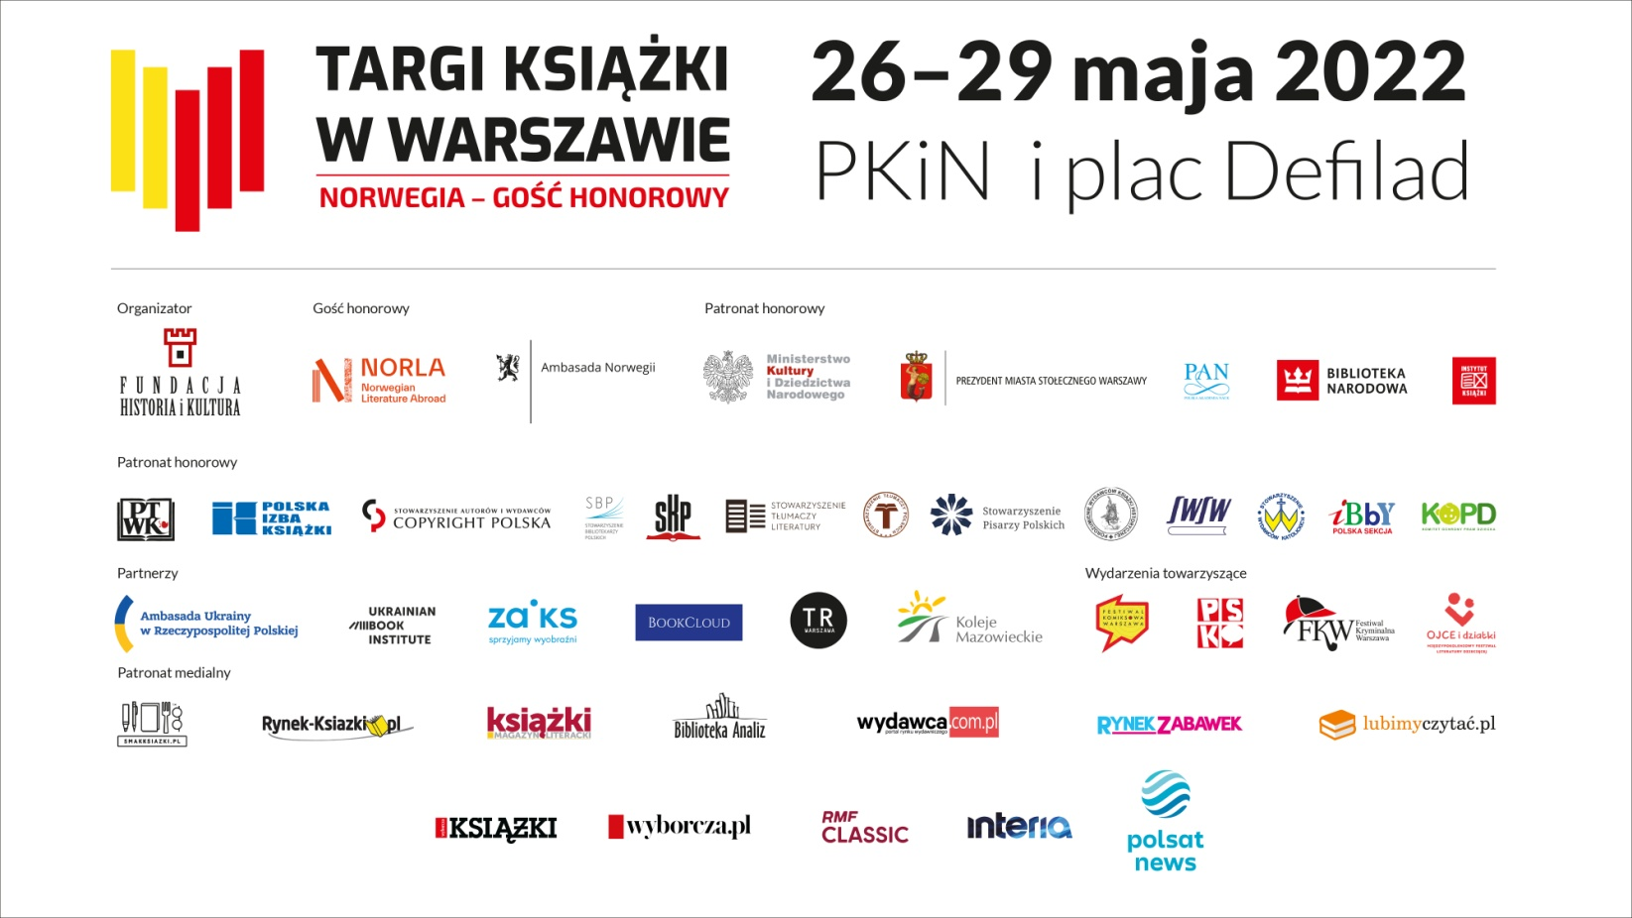 in Warsaw events.**