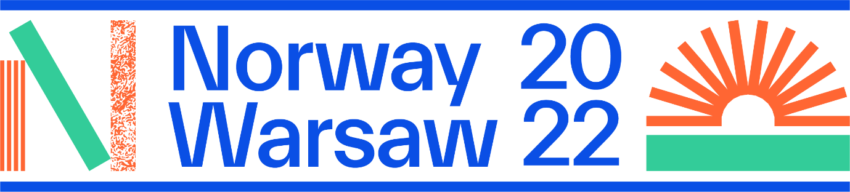

Extensive Norwegian program at the Book Fair in Warsaw 2022
Norway is the Guest of Honour at the Book Fair in Warsaw 26 – 29 May 2022. The book fair is an exciting opportunity to present a wide range of Norwegian literature in the Polish market. Several Norwegian authors will engage with their Polish audience and strengthen the connection between our two countries. “The Dream We Carry” is our slogan and we proudly present our program:
We are pleased that 30 authors from Norway are coming to Warsaw and will feature in 50 literary events during four days at the Palace of Culture and Science. You will find several series in our literary program: The daily program in the Norwegian tent will be kicked off with brave children and young adults’ literature. You will meet some of the best authors and illustrators from Norway. In “The Green Hour”, you will meet authors writing about nature, environment and travelling. In the series “Domestic Dilemmas”, you get an insight in Norwegian society and current issues, through fiction, and in “The Mysteries of Man” and “The Crime Hour” you will also get a glimpse inside the mind.
The program offer insight into the future and also the past: “The Classics’ Hour” and “WW2 in Norway” give you an introduction to two of Norway’s Nobel Prize Laureates and in World War II in Norway. Looking to our present day, we offer the series “Poetry Hour” including Ukrainian poetry, “European Feminists Anno 2022” and “European Literature Today”.
In Hall Marmurowa, you can visit our trade program, directed to book professionals. You can learn about translation, literary policies in Norway and Poland and two bilateral library projects.
Are you interested in languages? Visit our pop-up language course! Children are welcome to our creative workshops on Friday and Saturday.
Selected highlights will also be shown on the book fair’s own Main stage.
All events are either in Polish or available in Polish translation.
The authors participating are:
Malin Falch, Kristin Roskifte, Bjørn F. Rørvik & Per Dybvig, Bjørn Sortland and Monika Steinholm (Children and Young adults),
Lene Ask, Anders Kvammen and Anja Dahle Øverbye (Graphic Novels),
Marta Breen, Erika Fatland, Torbjørn Færøvik, Nina F. Grünfeld, Asbjørn Jaklin, Kaja Nordengen and Anne Sverdrup-Thygeson (Non-fiction),
Kjersti Anfinnsen, Marie Aubert, Cecilie Enger, Helga Flatland, Jørn Lier Horst & Thomas Enger, Klara Hveberg, Victoria Kielland and Nina Lykke (Fiction),
Aina Villanger (Poetry).
We are honored to also have Sami yoiker Biret Ristin Sara and author/yoiker Karen Anne Buljo on the program. DJs Charlotte Bendiks and Niilas will give you the beat of Norway.
Lene Ask, Anders Kvammen, Malin Falch and Anja Dahle Øverbye also participate in the comics festival Komiksowa Warszawa, which is held at the Palace of Culture and Science during the book fair.
In the Norwegian Tent, in front of the Palace of Culture and Science, you can buy Norwegian books in Polish translation from the independent booksellers Moda na Czytanie. They offer books from the authors on the program and other highlights from other authors from Norway.
The Guest of Honour project is organized by NORLA in close cooperation with the Royal Norwegian Embassy in Warsaw.
For updated info see our homepage: Warsaw 2022 - NORLA

The Book Fair in Warsaw is organized by Fundacja Historia i Kultura (the History and Culture Foundation).
Admission to the Book Fair in Warsaw is free of charge for all visitors.

The Book Fair will be open for the visitors on:
26.05.2022 from 10:00 AM to 6 PM
27.05.2022 from 10:00 AM to 7 PM
28.05.2022 from 10:00 AM to 7 PM
29.05.2022 from 10:00 AM to 5 PM

More info: The Book Fair in Warsaw

