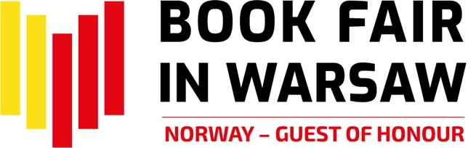

The Success of The Book Fair in Warsaw!

The Book Fair in Warsaw was held on May 26 – 29, 2022. The venue was Plac Defilad and the Palace of Culture and Science in Warsaw. This year's largest literary event was attended by over 500 exhibitors from 13 countries including Poland, Norway and Ukraine, as well as Armenia, Belgium, Czech Republic, France, Germany, Hungary, Romania, Spain, Switzerland, and the UK. Nearly 800 artists, including as many as 30 authors from Norway, who was the Guest of Honour at the Fair, met the audience on many stages. In total, over 1,000 events took place during the four days - meetings on stages and in dedicated zones, within 9 program blocks and at stands. According to estimates, the Fair was visited by approximately 90,000 people. Admission to the Book Fair in Warsaw was free for all visitors, and some of the events were also broadcasted on social media. The Book Fair in Warsaw was organized by the History and Culture Foundation.

Norwegian Literature
As the Guest of Honour, Norway’s slogan was The Dream We Carry. These words were written by Olav H. Hauge, a much-loved Norwegian poet, in his poem It Is That Dream. Among the authors from Norway who met the readers were: Jørn Lier Horst, Thomas Enger, Klara Hveberg, Victoria Kielland, Bjørn F. Rørvik, Per Dybvig, Erika Fatland, Torbjørn Færøvik, Nina F. Grünfeld, Kaja Nordengen, Anne Sverdrup-Thygeson. Norwegian literary program consisted of fifty events designed to reflect the contemporary literary landscape of the country. During The Children’s Hour and The Young Adults’ Hour, visitors met some of the best authors and illustrators from Norway. During The Green Hour, they were greeted by authors writing about nature, environment and travelling. In the series centred around Domestic Dilemmas they got insights on Norwegian society and current issues through fiction; and in The Mysteries of Man and The Crime Hour they also got a glimpse inside the human mind. Norwegian literary programme also revisited the past, with an introduction to Norway’s Nobel Prize winners and the history of the World War II in Norway. Back into the present day, readers could enjoy the following themes: The Poetry Hour, including Ukrainian poetry; European Feminists Anno 2022; and European Literature Today. On top of that, there was a Norwegian trade program with a multitude of events for book professionals, with such themes as translation, literary policies in Norway and Poland, or library projects. Every hour, students of Norwegian language offered a pop-up language course to give everyone a chance to learn the basics in just fifteen minutes. Norway’s literary programme at the fair was organized by NORLA (Norwegian Literature Abroad) in close collaboration with the Royal Norwegian Embassy in Warsaw.

Eye-to-eye with Ukrainian authors and publishers
Another highlight on the agenda was the close up on Ukrainian literature. The History and Culture Foundation, the organizer of the Fair, has invited publishers and authors from Ukraine, offering this country its own stand and space in the programme in the spirit of solidarity with Ukraine. At the same time, in keeping with the memorandum signed by the Board of Directors of International Book Fairs, decision was made to refuse fair invitation to Russian publishers, who used to have their own stand in Warsaw. The joint stand of the Ukrainian Book Institute promoted the publishing offer of nearly 35 publishing houses and institutions. Readers got an opportunity to meet some of the best known women authors from Ukraine, with Oksana Zabuzhko, who was asked to present a keynote speech at the opening ceremony, Viktoria Amelina, Tamara Duda, Lyubov Yakymchuk and Kateryna Kalytko. In cooperation with the Ukrainian Book Institute and the Embassy of Ukraine in Poland, books had been brought from Ukraine and were available for sale at the Fair. The presence of Ukrainian publishers at the Book Fair in Warsaw benefitted from symbolic financial support mobilized by the Book Institute in Poland.

Literary premieres, new releases, must-see events
The Fair was a perfect place to meet your favourite authors, buy their books and get autographs. There were a lot of opportunities to participate in literary premieres of such authors as Łukasz Orbitowski, Radek Rak, Wit Szostak, Mariusz Szczygieł, Victoria Kielland, Wojciech Chmielarz, Katarzyna Bonda, Vincent V. Severski, Maciej Siembieda, Magdalena Grzebałkowska and Ewa Winnicka, Katarzyna Tubylewicz, Magdalena Majcher, Lene Ask, Anja Dahle Øverbye and Adam Bodnar in conversation with Bartosz Bartosik, Urszula, Ullenka and Katarzyna Bareja. The Fair also hosted Jakub Małecki, Anna Gacek, Marta Grzywacz, Konstanty Gebert, Krystyna Kurczab-Redlich in conversation about Russia with Witold Szabłowski; Jagoda Ratajczak, Bożena Keff and Barbara Klicka, Krystyna Mirek, Katarzyna Barlińska, Monika Rutka, and Lucjusz T. Olszewski, Łukasz Mikołajewski and Sylwia Chutnik. Book lovers certainly did not miss the Thursday meeting with Douglas Stuart, the author of Shuggie Bain, the world's most famous literary debut in recent years, awarded the 2020 Booker Prize.

Crime stories, Warsaw of Comics and Children’s Literature Festival
The Fair was also accompanied by three literary festivals. Fans of crime literature had an opportunity to visit Kryminalna Warszawa sector and meet such big names as Wojciech Chmielarz, Katarzyna Bonda, Remigiusz Mróz, Vincent V. Severski, Maciej Siembieda, Anna Kańtoch, Anna Rozenberg, Robert Małecki, Ryszard Ćwirlej, Tomasz Duszyński, Krzysztof Domaradzki, Magdalena Majcher, Gaja Grzegorzewska, Anna Górna, Izabela Janiszewska, Bartosz Szczygielski, Przemysław Żarski, Agnieszka Jeż, Julia Łapińska and Małgorzata Starosta. The Kryminalna Warszawa Festival had also its own literary competition, whose winners were announced on Friday, May 27th. The winner of the Grand Prix of the Warsaw Criminal Festival 2022 was Wojciech Chmielarz for the novel Dług honorowy (Marginesy). Two other authors were also awarded: Krzysztof Domaradzki for Przełęcz (Wydawnictwo Literackie) and Julia Łapińska for the debut novel Czerwony Jezior (Agora). The Grand Prix award was sponsored by the Society of Authors ZAIKS.

The Warsaw of Comics Festival had an entire sector with publications, with more than fifty meetings and workshops with comic book authors and compelling exhibitions. The stars of this year's Festival included Lene Ask, Typex, Paco Roca, Javier de Isusi, and Tony Sandoval, to name a few. Among Polish authors there was Berenika Kołomycka, whose series for children Tiny Fox and Great Boar was brought out to the US and Norwegian markets this year; Jakub Topor, who is a Warsaw Literary Award nominee for his comic book Dziadostwo (Vol. 2 has just been published); and Wojciech Stefaniec, who - together with Daniel Odija – is the author of The Bardo series, recently sold to the Netherlands. Comic book fans were invited to enjoy workshops, buy the latest publications, meet their favourite authors and ask for a drawn signature. Warsaw of Comics Festival was organized by the Polish Comics Association.

For fantasy freaks, weekend zone was set up to accommodate meetings with best-selling authors, including, inter alia, Marta Kisiel, Katarzyna Miszczuk, Aneta Jadowska, Magdalena Kubasiewicz, Aneta Jadowska, Jakub Ćwiek, Gaja Grzegorzewska, Magdalena Salik, Jagna Rolska, Marcin Mortka, Arkady Saulski, and Jacek Galiński. This year’s themes focused on a female perspective on fantasy and on Ukrainian fantasy, alongside with adventure, military and children's fantasy. Last but not least, the winners of Nowa Fantastyka 2022 Award were announced.

There was also a variety of events targeted at young readers. On top of new releases and classics of children's and youth literature, the guests could enjoy meetings with the authors, writers, translators and illustrators.
On Thursday and Friday, groups of pre-schoolers and students were invited to join the workshops and meetings organized by publishers, Polish Literary Translators Association and by IBBY, with participation of Katarzyna Ryry, Kasia Boni, Edyta Jungowska, Marta Guśniowska, Marcin Przewoźniak, Aniela Cholewińska-Szkolik as well as the authors and illustartors from Norway: Bjørn F. Rørvik, Per Dybvig, Malin Falch, Anders Kvammen i Lene Ask. Courtesy of the Fathers and Children Cross-Generational Festival of Children's Literature, Saturday and Sunday were filled with workshops and meetings with Grzegorz Kasdepke, Kristin Roskifte, Malin Falch, Sylwia Chutnik, Ilona Wiśniewska, Yvette Żółtowska-Darska, Mirosław Wlekły, Marta Guśniowska, Magdalena Górska, Leszek Talko, Berenik Kołomycka, Piotr Socha, Maciek Kurek and Magdalena "Meago" Kania, Joanna Jagiełło, Justyna Bednarek and Nika Jaworowska-Duchlińska (illustrator), Krzysztof Łapiński and Marta Kurczewska (illustrator).

Warsaw Literary Zone
The Warsaw Reads programme, presented by the City of Warsaw, was among the most captivating attractions of the Fair. It offered children workshops and meetings inspired by Warsaw literary awards. This theme was presented by Justyna Sobolewska, Paweł Sołtys and Grzegorz Piątek. In turn, Justyna Bednarek and Piotr Socha talked about children's books, and comic books from Poland were discussed by Karolina Szymaniak, Szymon Holcman and Dominika Węcławek. This year's edition of the Book Fair in Warsaw was a real treat for non-fiction lovers. On the Non-Fiction Day, the authors nominated for the Ryszard Kapuściński Award, presented by the Warsaw City Council, were interviewed, and the winner was announced later on. In the 13th edition of the award, the following authors have been shortlisted: Peter Hessler (Buried. Life, Death and Revolution in Egypt), Rafał Hetman (Izbica, Izbica), Ander Izagirre (The Mountain that Eats Mene), Małgorzata Gołota (Spinalonga. The Leper Island). The laureate of this year's edition of the Award, Ander Izagirre, met with the audience on the main stage of the Fair on Sunday.

Trade and market, or a programme for book professionals
Business visitors, publishers, translators, illustrators, booksellers and librarians have had a dedicated agenda of meetings, debates and workshops. Book market professionals discussed such topics as readership in Poland (or rather the lack of it), the translator's profession, libraries across the ages, the status of the Ukrainian publishing industry and prospects for cooperation with EU markets, or how to write a children's book and make it a best-seller, to mention just a few.

Academic and scientific publications
During the Fair there were also a lot of academic and scientific book publishers, as the 15th edition of ACADEMIA Academic and Scientific Book Fair was celebrated this year. On Friday, the second day of the Fair, academic publishers received their recognition and awards, including those nominated in the ACADEMIA competition for the best academic and scientific book; the award of the Rector of Warsaw University of Technology for the best technical book for teaching; and the award of the Rector of University of Warsaw for the best academic publication in the field of social sciences and humanities. The ACADEMIA Prize was sponsored by the Society of Authors ZAIKS.

Award nominations and winners
During the Fair, the winners of the following prizes and awards were announced: ICARUS, presented by the Book Fair in Warsaw and the PTWK (Polish Society of Book Publishers) (ICARUS was sponsored by the Society of Authors ZAIKS), the 62nd edition of the Most Beautiful Books of the Year 2021 (PTWK), the 13th edition of the Ryszard Kapuściński Award, the Best Travel Publication Magellan Award, the Grand Prix of Kryminalna Warszawa Festival, Nowa Fantastyka awards, and the Butterfly Literary Award.

For more information and to see the calendar of events, please visit our website: https://targiksiazkiwarszawa.pl
and follows us on social media: Facebook | Instagram | Twitter | Norwegia na Targach Książki w Warszawie 2022

The Book Fair in Warsaw was open for the visitors on:

26.05.2022 between 10 am and 6 pm
27.05.2022 between 10 am and 7 pm
28.05.2022 between 10 am and 7 pm
29.05.2022 between 10 am and 5 pm

The admission was free of charge for the public.

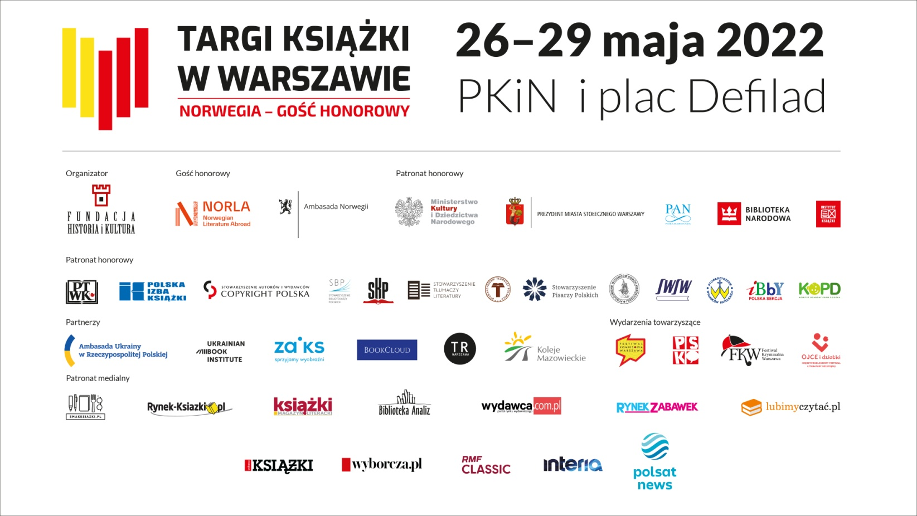
We would like to thank everyone who contributed to the Book Fair in Warsaw!

