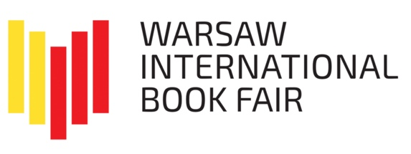

Warsaw International Book Fair

The next edition of the Warsaw International Book Fair will take place from 25 to 28 May 2023 at the Palace of Culture and Science and at Plac Defilad in front of the PKiN.
For publishers who would like to avoid the risk associated with the weather, we have prepared spaces on the second and fourth floors of the Palace of Culture and Science. For those for whom the partly open-air nature of the Fair is an advantage, there will be spaces in large and individual tents outside the Palace, in front of the main entrance and from the Kinoteka side.

The Warsaw International Book Fair is: the best location in the heart of Warsaw, a wide, international group of exhibitors; the presence of excellent creators: writers, translators or illustrators; a multithreaded program for lovers of literature, as well as for people professionally related to the publishing industry, including literary agents; cooperation with renowned partners: institutions and media; free admission with broadcast of selected events in social media; the largest audience in Poland; an experienced and proven organizer.

Last year, we hosted 90,000 lovers of literature at the Fair, breaking the attendance record of all Warsaw book fair events. We are already preparing for this year's edition and we are pleased to announce that our numerous and reliable audience will be waiting for, among others:
- Warsaw Criminal Festival
- Fathers and Children Cross-Generational Festival of Children's Literature
- Warsaw of Comics Festival
- Fantasy Zone

The Warsaw International Book Fair will also be accompanied by an extensive program of industry events and prestigious award ceremonies. At the fair, we will meet, among others: winners of:
- ICARUS Award for the author, presented by the Warsaw International Book Fair and PTWK (Polish Society of Book Publishers)
- 4th edition of the Competition for the Grand Prix of the Warsaw Criminal Festival
- 63rd PTWK Competition for The Most Beautiful Books of the Year 2022
- Competition for the best academic and scientific book ACADEMIA
- The Best Travel Publication Magellan Award

The Warsaw International Book Fair is the largest event in the publishing industry in the country, which last year was attended by over 500 exhibitors from several countries and a record audience. In 2022, during four fair days, over 1,000 trade fairs were held in total: events - meetings on stages and in zones, within 9 program blocks and at stands. Admission to the Fair is free for all visitors, and some events are registered and available online.

The activities of the History and Culture Foundation, focused on promoting reading and popularizing literature in Warsaw and other cities, brought excellent results last year. The Warsaw International Book Fair in May, under the honourable patronage of the Mayor of Warsaw, was successfully completed in the Palace of Culture and Science and outside, which was visited by a record-breaking 90,000 audience. In the opinion of the Norwegian partners from the Embassy of the Kingdom of Norway and NORLA, their presence as the Guest of Honour in Warsaw was very successful and fruitful.

In 2022, we also organized the premiere Autumn Book Fair in the Royal Castle Gardens and Kubicki Arcades in September, and the jubilee 30th Historical Book Fair. We conducted and resolved three competitions - for the Klio Award, the Academia Award and the Grand Prix of the Criminal Warsaw Festival, which enjoyed a record number of applications and media interest. Only the May Book Fair in Warsaw 2022 had a documented media reach of 42.2 million people. 71% of published/issued messages had a nationwide impact. (Based on the Report commissioned by the History and Culture Foundation by Press Service Monitoring Media).

Outside Warsaw, the Foundation also organized the Literary Open Air in Gdynia under the patronage of the Mayor of Gdynia, Wojciech Szczurek, and the Book Fair in Katowice in cooperation with the City of Katowice and under the patronage of the Mayor, Marcin Krupa. Thus, in 2022, we provided the public with 18 days of contact with the books and its creators, 1,380 authors took part in the events, 1,660 meetings with writers were held on the stages and exhibitors' stands. Last year's events of the History and Culture Foundation were attended by a total of 182,000 book lovers.

For more information visit:
bookfairwarsaw.pl as well as our Facebook profile
historiaikultura.pl

