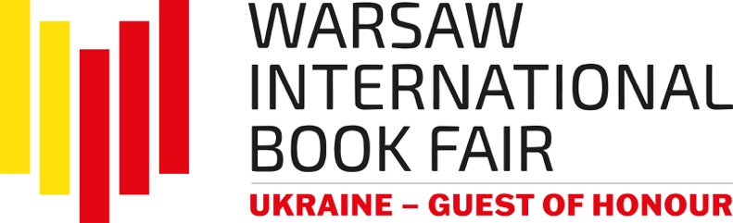

Ukraine as the Guest of Honour
Of the Warsaw International Book Fair

The Warsaw International Book Fair will be held this year from May 25th to 28th at the Palace of Culture and Science and at Plac Defilad with Ukraine being the Guest of Honour. The speech will be prepared by the Ukrainian Book Institute on behalf of the Ministry of Culture and Information Policy of Ukraine and the Embassy of Ukraine in Warsaw in close cooperation with the organizer of the Fair – the History and Culture Foundation.

At the beginning of the year, in response to the invitation of the History and Culture Foundation, official letters to the organizer of the Fair confirming cooperation in the organization of Ukraine's appearance as the Guest of Honour of the upcoming Warsaw International Book Fair were sent by the Ambassador Extraordinary and Plenipotentiary of Ukraine to the Republic of Poland, His Excellency Mr. Wasyl Zwarycz and the director of the Ukrainian Book Institute, Ms. Oleksandra Koval. Thanks to the involvement of the Embassy and the Ukrainian Book Institute, an over 200-meter national stand of Ukraine will be built at the Fair and a program of events with the participation of Ukrainian authors and publishers will be organized.

Today, contemporary Ukrainian literature is an extremely unique, important element of European civilization, because it is shaped by suffering, sacrifice and true heroism of the Ukrainian people who defend their homeland against Russian barbarism. It is an honour for us to accept the proposal for Ukraine to be the Guest of Honour of this year's Warsaw International Book Fair and we will make every effort to ensure that this event is held at the highest level. We would like to thank the organizer of the Fair – the History and Culture Foundation for such an honourable proposal and constant support for Ukraine. – says Ambassador Wasyl Zwarycz.

On behalf of the Ukrainian Book Institute, I would like to express my gratitude to the History and Culture Foundation for inviting us to participate in the formation of the "Ukraine — Guest of Honour of the Warsaw International Book Fair" program. Since the beginning of Russia's invasion of Ukraine on February 24, 2022, we have felt great cordiality and great help from the organizers and other state and non-state institutions operating in the cultural sphere, from writers, translators, publishers, practically from all Poles. Last year, the slogan of the Ukrainian stand at the Fair was "Thank you, Poland". This year we can repeat: "Poland, thank you a hundred times!". Participation in such a great international event, visited by hundreds of eminent authors from different countries, by crowds of wonderful audiences, especially in such a role, is an extremely important opportunity for Ukrainian intellectuals to present to the world the truth about Ukrainian history and culture, about the war as the heroes see it new books, to establish and deepen contacts with intellectuals from different countries. We believe in solidarity, perseverance and victory. Thank you, Poland! – says director Oleksandra Koval.

The Warsaw International Book Fair is the leading event in the publishing industry in the country, which is a continuation of the Book Fair in Warsaw. They are attended by an international group of exhibitors and creators: writers, translators and illustrators. The fair is accompanied by a multi-threaded program for literature lovers: festivals, thematic zones and industry events. Cooperation with renowned partners: institutions and the media, free admission with the transmission of selected events in social media and thousands of audience members are other advantages of the event.

In 2022, over 500 exhibitors from 13 countries took part in the Fair: Poland, Norway, Ukraine, as well as Armenia, Belgium, the Czech Republic, France, Spain, Germany, Romania, Switzerland, Hungary and Great Britain. Nearly 800 artists met the audience on many stages, including as many as 30 authors from Norway, which was the Fair's Guest of Honour. In total, over 1,000 events took place over four days – meetings on stages and in zones, as part of 9 program blocks and at stands. The fair was visited by about 90,000 people.

We are honoured to welcome partners from Ukraine in the role of the Guest of Honour. Giving voice to Ukraine today – certainly more than ever – we can see the role that literature plays in shaping timeless values such as freedom, dignity, honour, courage or a sense of community and solidarity. We are sure that the Warsaw International Book Fair will become a place to promote Ukrainian literature and culture among Polish and international audiences, as well as satisfy the need for contact with native literature among the Ukrainian community in Poland. We hope that the project "Ukraine – Guest of Honour of WIBF 2023", which is a key element of the program of this year's Fair, will significantly expand the group of lovers of Ukrainian literature, and Polish and Ukrainian publishers and authors will establish many interesting contacts for future cooperation – says Jacek Oryl, Director of the Warsaw International Book Fair.

The Warsaw International Book Fair will take place on May 25-28, 2023, at the Palace of Culture and Science in Warsaw and at Plac Defilad. Admission to all fair events is free, and selected meetings will be broadcast on the organizer's social media.

We would like to thank all the people and institutions with whom we create the Warsaw International Book Fair and invite you to cooperate on the project "Ukraine – Guest of Honour of the WIBF 2023".
History and Culture Foundation – organizer of the Warsaw International Book Fair.
Fair’s website: Warsaw International Book Fair
Social media profiles: Facebook | Instagram | Twitter |

The Warsaw International Book Fair, with free admission, is open to visitors:
25.05.2023 from 10:00 AM to 6:00 PM
26.05.2023 from 10:00 AM to 7:00 PM
27.05.2023 from 10:00 AM to 7:00 PM
28.05.2023 from 10:00 AM to 5:00 PM

