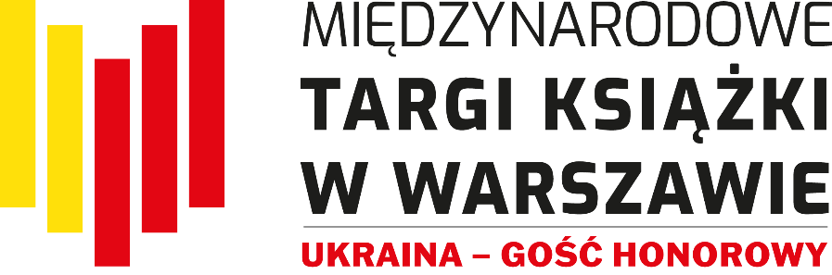

Millions of Bridges – the literary program of Ukraine
Guest of Honour of the Warsaw International Book Fair 2023

Ukraine is the guest of honour of the Warsaw International Book Fair, which will be held on May 25-28, 2023 at the Palace of Culture and Science and at Plac Defilad, in front of the main entrance to the Palace of Culture and Science and from the Kinoteka side. The speech will be an opportunity to present a wide range of contemporary Ukrainian literature to a wide audience. They will be prepared by the Ukrainian Book Institute, on behalf of the Ministry of Culture and Information Policy of Ukraine, and the Embassy of Ukraine in Warsaw, in cooperation with the organizer of the Fair - the Fundacja Historia I Kultura. Literary events with the participation of authors and publishers from Ukraine will be held under the slogan "Millions of bridges" and will certainly contribute to better understanding and deepening the ties between the two countries.
The stand of Ukraine - the Guest of Honour of the MTKW will be located in the Marmurowa Hall of the Palace of Culture and Science at number 120. You will be able to buy books in Ukrainian from the offer of about 45 publishers, meet Ukrainian authors and representatives of the literary world, establish industry contacts with agents and publishers. The place for meetings with the audience at the Ukrainian stand will accommodate selected events and a corner with activities for children. Independently, at the Fair in the Palace of Culture and Science, there will be a bookshop with books by Ukrainian authors in Polish translation and publications about Ukraine.
Over 30 outstanding authors from Ukraine will come to Warsaw and will take part in 40 literary events during the four days of the fair, including: Jurij Andruchowycz, Ostap Sływynski, Jurij Wynnyczuk, Switłana Taratorina, Kateryna Babkina and Hałyna Kruk.
A rich program of events promoting Ukrainian culture and literature, in which everyone will find something for themselves, will include meetings with authors, literary discussions and autograph sessions. There will also be classes for the youngest readers and a performance with the participation of musicians from Ukraine on the open-air stage of the Fair. Industry events will include meetings devoted to literary translations and the current situation of the Ukrainian publishing market, as well as the prestigious Drahoman Award Gala, organized by the Ukrainian Institute and partners: Ukrainian Book Institute and Pen-Ukraine.
The Fair will also host a joint Polish-Ukrainian literary project - the festival "The Power of the Word - Polish-Ukrainian Literary Dialogues". It is a series of meetings and talks of writers, journalists, intellectuals from Poland and Ukraine, serving the purpose of presenting achievements and exchanging ideas, which emphasizes the role of literature in shaping timeless values such as freedom, dignity, honour, courage or a sense of community and solidarity, which are so important in when there is a war going on outside our border.
The program of the festival was created in cooperation with the Book Institutes of Ukraine and Poland and the organizer of the Fair, thanks to co-financing from the Minister of Culture and National Heritage funds.
Writers from Ukraine will be accompanied in literary conversations by outstanding Polish authors, including.: Andrzej Sapkowski, Jakub Małecki, Justyna Bednarek, Bohdan Zadura, Paweł Sołtys, czy Rafał KosikThe meetings will be held in Polish and Ukrainian, with literature lovers from both countries in mind. Most of them will be recorded and made available on MTKW FB and the YT channel of the Fundacja Historia I Kultura.
The Warsaw International Book Fair is the leading event in the publishing industry in the country, which is a continuation of the Book Fair in Warsaw. Nearly 500 exhibitors and several hundred outstanding artists from Poland and 14 other countries participate in them: Austria, Azerbaijan, China and Taiwan, France, Spain, India, Iceland, South Korea, Germany, Norway, Romania, Slovakia, Italy and Ukraine - which is the Guest of Honour of this year's edition.
The fair is accompanied by a multi-threaded program for lovers of literature: festivals, thematic zones and industry events, including: Warsaw Comics Festival, Criminal Warsaw Festival, Reportage Day with the Ryszard Kapuściński award, the Intergenerational Children's Literature Festival "Fathers and Children", the "Reading for Democracy" Conference and the "Power of the Word" Festival, Polish-Ukrainian literary dialogues.
During the Fair, we will get to know the winners of the following awards: IKAR - awards of the International Book Fair in Warsaw and PTWK for the author, 63rd PTWK Competition The Most Beautiful Books of the Year 2022, 14th Ryszard Kapuściński Award, Magellan Awards in the competition for "The best tourist publications", Competition for the Grand Prix of the Criminal Warsaw Festival, The “New Fantasy” Awards, ACADEMIA competition for the best academic and scientific book and the competition "Piórko 2023. Biedronka Award for a children's book".
The events will take place on two stages and in seven halls over the four days of the Fair. The visitors will also be able to meet the authors and ask for autographs at the publishers' stands. Selected points of the program will be broadcast on the Fair's social media.
The organizer of the Warsaw International Book Fair is Fundacja Historia i Kultura.
„Ukraine - Guest of Honour of the Warsaw International Book Fair 2023”. Public task financed by the Ministry of Foreign Affairs of the Republic of Poland in the "Public Diplomacy 2023" competition.
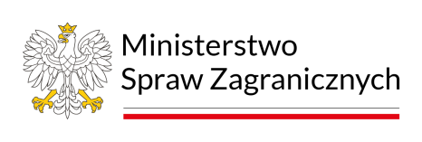

Co-financed by the Minister of Culture and National Heritage as part of the task "Strength of Word - literary Polish-Ukrainian dialogues”.

Admission to the Fair and participation in events is free for all visitors.
Opening days and hours:
25.05.2023 r. from 10:00 to 18:00
26.05.2023 r. from 10:00 to 19:00
27.05.2023 r. from 10:00 to 19:00
28.05.2023 r. from 10:00 to 17:00

targiksiazkiwarszawa.pl
Facebook | Instagram | Twitter
Contact:
Małgorzata Kanownik – program and PR coordinator, Fundacja Historia i Kultura
program@historiaikultura.pl, +48 505 245 837
Oleksandra Koval – director of the Ukrainian Book Institute
oleksandra.koval@ubi.org.ua and WhatsApp +380503221085
