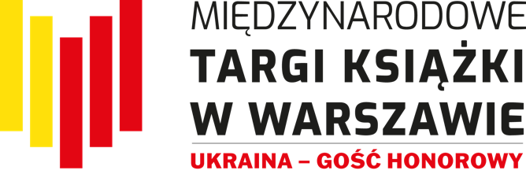
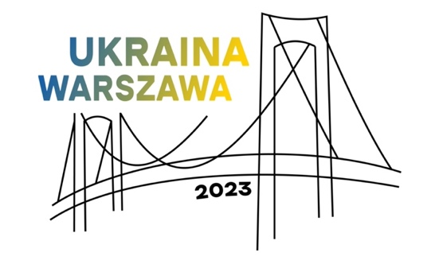

Stay tuned for the International Book Fair in Warsaw

This year’s edition of the Book Fair in Warsaw is held on May 25-28: indoors, at the Palace of Culture (the PKiN), and outdoors, in front of the Main Entrance and Kinoteka Multiplex. The biggest literary event of the year will host nearly 500 exhibitors and a line-up of bestselling authors from Poland and 14 different countries: Austria, Azerbaijan, China and Taiwan, France, Germany, Iceland, India, Italy, Norway, Romania, Slovakia, South Korea, Spain and - last but not least – Ukraine, who is the Guest of Honour. The Fair will be attended by nearly 1000 authors, translators, illustrators, publishing industry actors and culture icons. Three stages and seven halls will host nearly 270 meetings, not to mention more than 500 events organized in publishers' pavilions. Visitors can choose from close to 800 events scheduled over the four days of the Fair.
Admission is free; selected events will be streamed on social media channels. The Book Fair in Warsaw is organized by the History and Culture Foundation.

Millions of Bridges: presentation of Ukrainian literature
A rich and varied offer of contemporary Ukrainian literature will be presented by the Book Institute in Ukraine (under the auspices of Ukrainian Ministry of Culture and Information Policy) and the Embassy of Ukraine in Warsaw, in cooperation with Fair organiser, the History and Culture Foundation.
Millions of Bridges is a motto that aptly reflects the spirit of Ukrainian exhibition this year. Russian aggression, which destroyed Ukrainian cities and caused countless fatalities and injuries, has also triggered something that the attackers did not expect to see: it built millions of bridges between people of Poland and people of Ukraine. Polish solidarity and hospitality have been a ray of light amidst the struggle.
At the Ukrainian exhibition stand in the Marble Hall (No. 120), forty-five publishers will promote books in Ukrainian. There will be meetings with authors and literary icons, plus many networking opportunities. In addition, a bookshop with Polish translations of Ukrainian books and with publications on Ukrainian themes will operate in the Main Hall (No. 100 A).
Warsaw will host more than twenty Ukrainian authors and creators; during the four days of the Fair they will participate in nearly sixty meetings.
Fans of Ukrainian literature, including Ukrainians living in Poland, can choose from a broad selection of events, including meetings with authors, literary debates or autograph sessions, with the participation of Yuri Andrukhovych, Ostap Slyvynsky, Yuri Vynnychuk, Svitlana Taratorina, Kateryna Babkina and Halyna Kruk, to mention just a few. Ukrainian publishers will talk about their operation during the first year of a full-scale war in Ukraine and about all the things that will need to change because of the war. There will also be activities for children, musical performance on the open-air stage, and an exhibition of posters by the Pictoric art collective, entitled “Ukraine Yesterday and Today”.
Another highlight of Ukrainian presence at the Fair is a Polish-Ukrainian literary festival "Word Power: Polish-Ukrainian Literary Dialogues", with a series of meetings and discussions with writers, journalists and intellectuals from Poland and Ukraine sharing their thoughts and ideas on how literature can promote freedom, respect, honour, courage and solidarity, especially now that there is a full-scale war across our border. Side by side with Ukrainian writers, a number of prominent Polish authors will join in, including Andrzej Sapkowski, Jakub Małecki, Justyna Bednarek, Bohdan Zadura and Rafał Kosik. Discussions will be held in Polish and in Ukrainian so as to attract book lovers from both countries.
The programme of " Word Power: Polish-Ukrainian Literary Dialogues" has been developed by Book Institutes from Ukraine and Poland, in collaboration with the organiser of the Fair and with financial support from Polish Ministry of Culture and National Heritage.
The presence of Ukraine as the Guest of Honour at the 2023 International Book Fair in Warsaw benefits from financial support of Polish Ministry of Foreign Affairs.
For more information about Ukrainian presence at the Fair, please visit: Szczegóły programu Ukrainy na Targach

Literary launches, new releases, must-sees
The Fair is a perfect place to meet your favourite authors, buy their books and get autographs. Visitors can meet Jerzy Bralczyk, Andrzej Sapkowski, Joanna Bator, Zyta Rudzka, Łukasz Orbitowski, Jakub Małecki, Adam Wajrak, Justyna Kopińska, Katarzyna Włodkowska, Anna Bikont and Joanna Szczęsna, Wit Szostak, Radek Rak, Rafał Kosik, Remigiusz Grzela, Martyna Bunda, Aleksander Kwaśniewski and Aleksander Kaczorowski, Tadeusz Rolke and Chris Niedenthal, Artur Andrus, Janina Bąk, Maria Karpińska, Stanisław Brejdygant, Miriam Synger, Marek Sygacz, Marek Łuszczyna, Dawid Karpiuk, Andrzej Kohut, Weronika Rokicka, Dominik Héjj and Mateusz Mazzini, inter alia, who will speak during a number of indoor and outdoor events.
In addition to a large group of Ukrainian creators, foreign guests will include B.A. Paris, Roy Jacobsen and Anneliese Pitz, Li Ang, Won-Pyung Sohn, Viola Ardone, Marisa de Lempicka, Milena Michiko Flašar, Daniel Wisser, Tomáš Forró, Uladzimir Arlou, Yakov Shechter and Victor Jestin, inter alia.
You do not want to miss literary premiers and pre-launch meetings with Yrsa Sigurðardóttir, Konstanty Gebert, Paweł Potoroczyn, Maciej Siembieda, Wojciech Chmielarz, Małgorzata Oliwia Sobczak, Magdalena Kordel, Maciej Wojtyszko, Justyna Suchecka and Shin Kyung-Sook, inter alia.
Book lovers traditionally appreciate the festivals that accompany the Fair, including Komiksowa Warszawa (Warsaw of Comics Festival), Kryminalna Warszawa (Warsaw Crime Festival), the Non-Fiction Day with Ryszard Kapuściński Award, and Ojce i dziatki Cross-Generational Festival of Children's Literature. There will be two major events for industry players: “Readership for Democracy” and “Traditions of German foreign policy towards Central and Eastern Europe” as part of the cycle on “Poland-Russia-Germany. From the 18th to the 21st century” (a conference supported financially by Polish Ministry of Education and Science from Socially Responsible Science allocation).
For more information about the schedule of events on the stages and in the halls, please visit: Program spotkań na scenach i w salach
For more information about the schedule of events at exhibition stands, please visit: Program spotkań na stoiskach

Warsaw of Comics Festival, Warsaw Crime Festival and Children’s Literature Festival
The Fair is accompanied by three literary festivals. Fans of crime literature must visit Kryminalna Warszawa sector and meet their favourite crime story writers, including Yrsa Sigurdardóttir, B.A. Paris, Wojciech Chmielarz, Maciej Siembieda, Anna Kańtoch, Joanna Opiat-Bojarska, Małgorzata Oliwia Sobczak, Julia Łapińska, Grzegorz Dziedzic, Małgorzata Starosta, Jacek Galiński, Beata and Eugeniusz Dębscy, Magda Stachula, Grzegorz Kapla, Piotr Rozmus, Jakub Bączykowski and Karolina Głogowska. The festival has its own literary competition; Grand Prix winners will be announced on Friday, May 26th, at 6 pm, on the outdoor stage; meeting with the audience will be held on Saturday, at 3 pm, in the Kisielewski Hall. The Grand Prix is sponsored by ZAIKS Society of Authors.
For more information about Warsaw Crime Festival, please visit: Festiwal Kryminalna Warszawa - program

Komiksowa Warszawa will have an entire sector with publications (pavilion C next to the Kinoteka entrance, pavilion E, and indoor space), not to mention more than fifty meetings and workshops with comic book authors. Three exhibitions have been prepared in the Starzyński Hall on the 4th Floor (PKiN). Creators and publishers are invited to the Sienkiewicz Hall on Wednesday (PKiN); and all those interested in women's programme will want to visit the Mickiewicz Hall (PKiN) on Sunday. The stars of this year's festival include a number of international guests: Marcelo Quintanilha, Jordi Bayarri, Vojtěch Mašek, Guido van Driel, Frenk Meeuwsen, Wagner Willian, Peter Milligan, Martin Šinkovský, Jan Pomykači; and Polish authors: Tomasz Niewiadomski, Rafał Skarżycki, Tomasz Leśniak, Edyta Bystroń, Unka Odya, Monika Laprus-Wierzejska, Anna Poszepczyńska, Jakub Topor, Jacek Świdziński, Marcin Podolec, and many others. Comic book fans can enjoy workshops, buy the latest publications, meet their favourite authors and ask for a drawing/autograph (to get to the Autograph Zone check out Column Hall at the Kinoteka Multiplex, Friday through Sunday). Warsaw of Comics Festival is organized by the Comics Association in Poland.
For more information about Warsaw of Comics Festival, please visit: Festiwal Komiksowa Warszawa - program

For children and young adults
There is a variety of events designed for young readers. New releases and all-time classics will be promoted by writers, translators and illustrators specializing in children’s books. On Thursday and Friday, groups of pre-schoolers and school students are invited to join the workshops and meetings organized by the Powergraph, Instytut Książki Publishing House, Polish Literary Translators Association and Polish Section of IBBY, Olesiejuk Publishing House, Sensus Publishing House, Committee for the Protection of Children's Rights and the Empowering Children Foundation. You can meet Rafał Kosik and Paulina Mechło, inter alia; and learn more about most recommended books, Internet safety and school violence; and attend interesting literature and art workshops.

Courtesy of the Fathers and Children Cross-Generational Festival of Children's Literature, the weekend will be filled with exciting workshops and meetings. Justyna Bednarek and Maciej Szymanowicz will talk about the fairytale nature of Polish countryside, Tomasz Samojlik and Adam Wajrak will guide you along a trail of bird riddles, Marta Guśniowska will address the big issues of the little people, comic book lovers will have an opportunity to talk to Jordi Bayarri (Graphic Science Biographies), Robert Czajka and Ewa Solarz will introduce Planet Earth according to Alien statistics, Elias and Agnieszka Våhlund will turn us all into superheroes, and Maciej Kur and Magdalena Meago Kania will present comics worth eating. Agata Romaniuk and her Kocia Szajka gang will invite us to play a game and solve detective puzzles, while Barbara Sadurska will take children to the Land of the Silver Dragon. Józef Wilkoń, a renowned illustrator, painter, drawer and sculptor, will reveal some of the secrets of the trade, Alix Maiwenn will touch upon the subject of control and freedom, and Anna Paszkiewicz will talk about the fact that we are as different as two drops of water but together we create an ocean. Scheduled events by reservation only.
For more information about attractions for children and young adults, please visit: Program dla dzieci i młodzieży

Warsaw Literary Zone
The programme developed by the City of Warsaw has been among the most captivating attractions of the Fair. It offers a broad range of meetings, workshops and panel discussions. Make sure to visit City of Warsaw exhibition stand (pavilion A in front of the Main Entrance, number 4/A) to meet Agata Tuszyńska, Małgorzata Halber and Łukasz Orbitowski. The pavilion will host free workshops and meetings for the youngest audience: family workshops organized by the Museum of Warsaw (Zdarzyło się w Warszawie), detective workshops with Agata Romaniuk (Kocia Szajka), and fine arts workshops with Marta Ignerska and Marta Lipczyńska-Gil (Ferment w mieście).
City of Warsaw is also responsible for a series of literary debates to be held on the Main Stage (on the 4th Floor): Małgorzata Żarów and Łukasz Krukowski will be discussing Polish apocalyptic prose; Agata Romaniuk and Rafał Witek will explain how to read for children and with children; and Michał Rzecznik and Aleksandra Herzyk will talk about adventures in Polish comic books.
Non-fiction lovers definitely want to be in the Lviv Hall on Saturday to meet the authors shortlisted for Ryszard Kapuściński Award, presented by Warsaw City Council and co-hosted by Gazeta Wyborcza. In the 14th edition of the award, the following writers have been shortlisted: Ilona Wiśniewska for Migot. Z krańca Grenlandii, published by Wydawnictwo Czarne (interview by Natalia Szostak); Anna Goc for Głusza, published by Wydawnictwo Dowody (interview by Natalia Szostak); Christina Lamb for Our Bodies, Their Battlefield, published by Wydawnictwo Znak Literanova (interview by Michał Nogaś), Anna Bikont for Cena. W poszukiwaniu żydowskich dzieci po wojnie, published by Wydawnictwo Czarne (interview by Wojciech Szot), Jakub Sieczko for Pogo, published by Wydawnictwo Dowody (interview by Wojciech Szot). Non-Fiction Day will be hosted by Michał Nogaś. On Sunday, a meeting with this year's winner of Ryszard Kapuściński Award will be held on the Main Stage (on the 4th Floor).
At the City of Warsaw exhibition stand (pavilion A in front of the Main Entrance, No. 4/A) you can find books nominated for and awarded with Warsaw literary prizes: City of Warsaw Literary Award, Ryszard Kapuściński Award and Kazimierz Moczarski Warsaw Historical Award.
For more information about events organized by the City of Warsaw, please visit: Program warszawski
For book market professionals
Book market professionals can choose from a total of almost forty meetings, debates and workshops for publishers, translators, illustrators, librarians and teachers. A wide range of diverse and relevant issues will be addressed, such as the role of literature in supporting development of children and teenagers: books that help create a child-friendly world; national and global trends in children's non-fiction, educational or popular science books; how to translate books for teenage audience; what messages are communicated by new Polish literature for children and teenagers and for what audience are they written; first-aid books, i.e., how a book can help a young reader; Polish Book Institute's nationwide readership campaign (Mała książka - wielki człowiek). Other themes include artificial intelligence and its application in everyday operation of cultural institutions; how to achieve zero waste on the publishing market; how to safeguard author’s control on the publishing market; Polish book market through the lens of Nielsen BookScan Polska; cooperative publishing models for open access scientific books; future of literary magazines in the digital era; the role of books in the lives of generation 60+; and how to organise a very special event at a library during the Night of Libraries. There will be industry events dedicated specifically to Ukraine, with such themes as the Ukrainian book market in the state of war and how to support Ukrainian book market now and once the war is over; the art of translating Ukrainian poetry and theatre plays.
Industry programme partners include Polish Chamber of Books, Polish Society of Book Publishers, Book Institute in Poland, Association of Polish Librarians, Association of Literary Translators, Polish Section of IBBY, Centre for Citizenship Education, Committee for Protection of Children's Rights, Nielsen BookData.
For more information about industry events, please visit: Program dla branży
Prizes and awards
During the Fair, the winners of the following prizes and awards will be announced: ICARUS, presented by the Book Fair in Warsaw and the Polish Society of Book Publishers (sponsored by ZAIKS Society of Authors); the 63rd edition (2022) of the competition for Most Beautiful Books of the Year, organized by the Polish Society of Book Publishers; the 14th edition of Ryszard Kapuściński Award; Magellan Award for the Best Travel Publication; the Grand Prix of Kryminalna Warszawa Festival (the Main Prize is sponsored by ZAIKS Society of Authors); and “Piórko 2023. Biedronka Children's Book Prize competition”.

Over the four days of the Fair, the events will be held on three stages and in seven halls. Authors will also be available for meet and greet at the publishers' stands. Selected highlights will be broadcast on social media channels.
The International Book Fair in Warsaw is organized by the History and Culture Foundation.
“Ukraine - Guest of Honour at the 2023 International Book Fair in Warsaw”. Public purpose task financed by the Ministry of Foreign Affairs of the Republic of Poland as part of “Public Diplomacy 2023”.
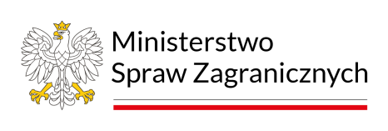
Financially supported by the Ministry of Culture and National Heritage of the Republic of Poland as part of the “Word Power: Polish-Ukrainian literary dialogues”.
Free admission and participation for all.

Opening hours:
25 May 2023: from 10 am to 6 pm
26 May 2023: from 10 am to 7 pm
27 May 2023: from 10 am to 7 pm
28 May 2023: from 10 am to 5 pm

targiksiazkiwarszawa.pl
Facebook | Instagram | Twitter

Contact person:
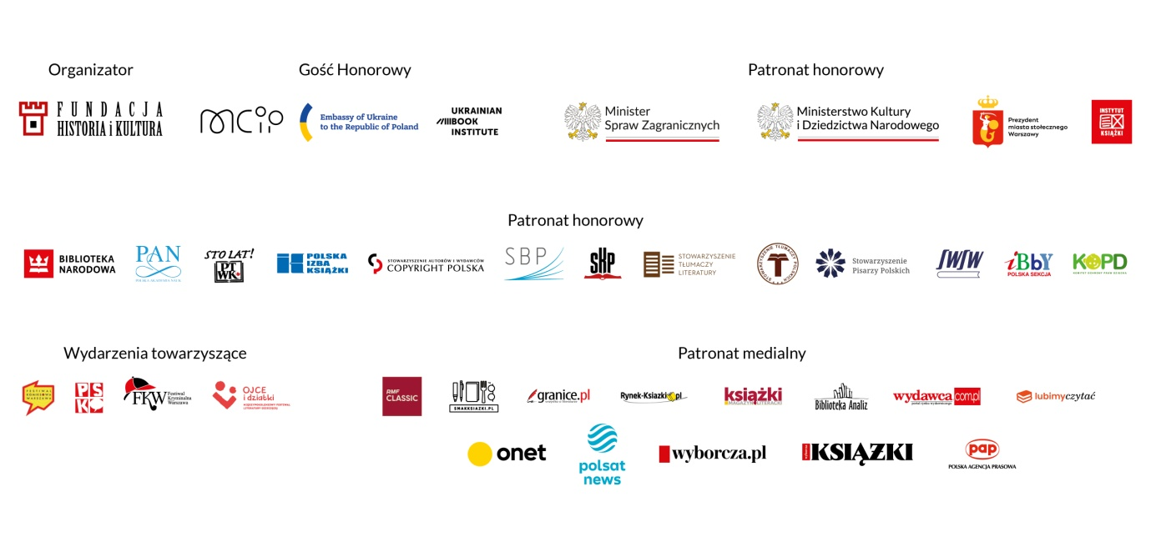
Małgorzata Kanownik, Content and PR Coordinator, Fundacja Historia i Kultura program@historiaikultura.pl, +48 505 245 837

