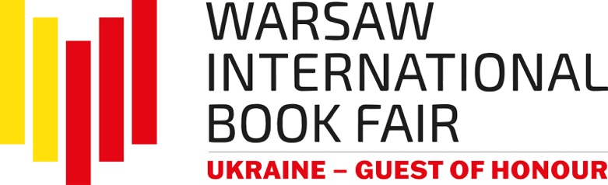
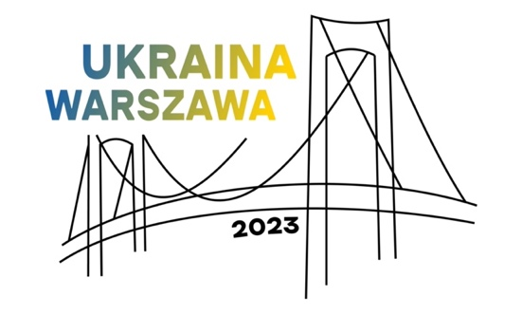

The Warsaw International Book Fair, held on May 25-28 at the Palace of Culture and Science and outside, in front of the Main Entrance and Kinoteka Multiplex (for the first time), was the biggest literary event of the year, hosting nearly 500 exhibitors and a line-up of bestselling authors from Poland and fourteen other countries: Austria, Azerbaijan, China and Taiwan, France, Germany, Iceland, India, Italy, Norway, Romania, Slovakia, South Korea, Spain and Ukraine, the Guest of Honour. The Fair was attended by approximately 1000 authors, translators, illustrators and publishing industry and culture managers. Three stages and seven halls hosted nearly 270 meetings, on top of more than 500 events organized in publishers' pavilions. Altogether, close to 800 events were held during the Fair. It is estimated that the Warsaw International Book Fair attracted more than 100k visitors this year.
Admission was free and selected events were streamed on social media channels. The Warsaw International Book Fair is organized by the History and Culture Foundation.

‘We are very pleased with excellent turnout of exhibitors and visitors during the entire event. The audience appreciated our diverse literary and commercial programme, the rich publishing offer, and the new spatial arrangement: pavilions were set up not only in front of the Main Entrance to the Palace, but also in front of Kinoteka Multiplex; and the stands inside the Palace got a new, improved layout. The turnout was even greater thanks to the free admission policy, with all attractions available free of charge. We are delighted to see growing numbers of teenagers and young adults enjoy the Fair. We plan to cater to this segment of the audience during future editions as well. We have received very positive feedback from publishers and other participants. We are excited about the success of our formula, which is made from several key ingredients: an event for international exhibitors and industry actors; an impressive and extensive festival section supported by a number of patrons and partners; the unique venue; free admission policy. This winning combination sets us apart from other local and national events. The next edition of the Warsaw International Book Fair is scheduled for May 23-26, 2024. The Guest of Honour will be Italy.

We embraced the opportunity to promote Ukrainian culture and literature as this year’s Guest of Honour. More than 20 authors and 45 publishers, translators, illustrators and book market professionals were invited to present Ukrainian culture and literature, building ‘Millions of Bridges’. This was a highlight of the agenda and one of the strongest points of the entire event. At the opening ceremony, we were honoured and pleased to hear from Ruslan Stefanchuk, Chairman of the Verkhovna Rada of Ukraine; Olena Zelenskaya, the First Lady, who is a keen supporter of Ukrainian literature, and Oleksandr Tkachenko, Ukrainian Minister of Culture and Information Policy. There is no doubt that Ukraine attached great importance to their role of the Guest of Honour during the Warsaw International Book Fair’, says Jacek Oryl, the Director of the Warsaw International Book Fair.

The tagline of the Ukrainian presentation at the Fair read ‘Millions of Bridges’. At the Ukrainian exhibition stand, forty-five publishers promoted books in Ukrainian. A number of meetings with writers and creators were held here, and a children's corner was organized. In the main hall of the Palace, a bookshop was set up to promote Polish translations of Ukrainian books, side by side with publications dedicated to the themes associated with Ukraine.

More than twenty Ukrainian writers and creators came to Warsaw to participate in nearly sixty literary meetings, including Yuri Andrukhovych, Ostap Slyvynsky, Yuri Vynnychuk, Svitlana Taratorina, Kateryna Babkina, Halyna Kruk, Yaryna Czornohuz, Dmytro Kuzmienko, Iryna Danyevska, Vakhtang Kebuladze, Andriy Kuhut, Kyrylo Malov, Yevgeniya Podobna, Maria Shahuri and Yuri Zavadsky. Ukrainian publishers shared their experience and opened up about their operation during the first year of a full-scale war in Ukraine and about all the changes resulting from the war.

Another highlight of Ukrainian presence at the Fair was Polish-Ukrainian literary festival called ‘Word Power: Polish-Ukrainian Literary Dialogues’, with a cycle of meetings and discussions with writers, journalists and intellectuals from Poland and Ukraine, who were sharing thoughts and ideas on how literature can promote universal values at the time of war just across Polish the border. Ukrainian writers were joined by a number of prominent Polish authors, including Andrzej Sapkowski, Jakub Małecki, Justyna Bednarek, Bohdan Zadura and Rafał Kosik.

The festival was prepared by Book Institutes from Ukraine and Poland, in collaboration with the organiser of the Fair and with financial support from Polish Ministry of Culture and National Heritage. The project ‘Ukraine as the Guest of Honour at the 2023 Warsaw International Book Fair’ was support with the funds from Polish Ministry of Foreign Affairs.

‘The books are part of Ukraine's national identity, which we must defend just as we defend our country against Russian aggression. Russia has been trying to destroy Ukrainian nation and culture. The literary front is becoming increasingly important and is helping Ukraine in its fight for freedom.

With Ukraine being the guest of honour at the Warsaw International Book Fair, we are able to bring Ukrainian literature centre stage. Ukraine and Poland once again showed the world that we are friends indeed. Together we can prevail over the forces of evil and build a better tomorrow for our peoples’, comments H.E. Vasyl Zvarych, Ambassador of Ukraine to Poland.

‘On behalf of the Ukrainian Book Institute, Ukrainian publishers, authors, translators and illustrators, I would like to express our gratitude to the History and Culture Foundation, the Polish Book Institute, the Polish Chamber of Books, Polish Ministry of Culture and National Heritage, Polish Ministry of Foreign Affairs, and the Embassy of Ukraine in Poland, thanks to whom Ukraine could make such an impressive appearance at my favourite Book Fair in Warsaw. We make every effort to establish and strengthen the ties of cooperation and understanding between Poland and Ukraine. This year's edition of the Fair represents yet another strong pillar of the bridge that our two nations are building hand in hand on the way to victory over the enemy and continued development of democracy in our countries and around the world. For Our Freedom and Yours!’, declares Oleksandra Koval, Director of the Ukrainian Book Institute, in conclusion of Ukrainian presentation as the Guest of Honour of 2023 Warsaw International Book Fair.

Apart from Ukraine, books from Spain, France, Germany, Norway and Romania were presented, and the Nordic exhibition stand featured Danish, Swedish, Finnish and Icelandic literature.

Readers could meet their favourite authors and literary award winners, including Prof. Jerzy Bralczyk, Andrzej Sapkowski, Joanna Bator, Zyta Rudzka, Łukasz Orbitowski, Jakub Małecki, Adam Wajrak, Justyna Kopińska, Katarzyna Włodkowska, Anna Bikont and Joanna Szczęsna, Wit Szostak, Radek Rak, Rafał Kosik, inter alia.

In addition to an impressive representation of Ukrainian creators, foreign guests included B.A. Paris, Roy Jacobsen and Anneliese Pitz, Li Ang, Won-Pyung Sohn, Viola Ardone, Marisa de Lempicka, Milena Michiko Flašar, Daniel Wisser, Tomáš Forró, Uladzimir Arlou, Yakov Shechter and Victor Jestin, inter alia.
Many publishers chose the Warsaw International Book Fair for their literary premiers and pre-launch meetings, including the books of Yrsa Sigurðardóttir, Konstanty Gebert, Wojciech Chmielarz and Shin Kyung-Sook, inter alia.

The Non-Fiction Day attracted big crowds for the interviews with authors of books shortlisted for the 14th edition of Ryszard Kapuściński Memorial Award, including this year's winner, Anna Goc, who received the award for ‘Głusza’, (Wydawnictwo Dowody). The City of Warsaw exhibition stand proudly presented books nominated for and awarded with Warsaw literary prizes: City of Warsaw Literary Award, Ryszard Kapuściński Memorial Award and Kazimierz Moczarski Warsaw Historical Award.

Long list of competitions and winners announced during the Warsaw International Book Fair includes the 63rd edition of the competition for the Most Beautiful Books of the Year, organized by the Polish Society of Book Publishers; the Grand Prix of Kryminalna Warszawa Festival; Academia 2023 Competition for the best academic and scientific publications; ICARUS, presented to this year’s winner, Marcin Szczygielski, by the Warsaw International Book Fair and the Polish Society of Book Publishers (sponsored by ZAIKS Society of Authors); the 14th edition of Ryszard Kapuściński Memorial Award; Magellan Award for the Best Travel Publication; Nowa Fantastyka Awards; ‘Piórko 2023. Biedronka Children's Book Prize competition’.

Book lovers enjoyed a variety of festivals and industry events that accompanied the Fair, including Komiksowa Warszawa (Warsaw of Comics Festival), Kryminalna Warszawa (Warsaw Crime Festival), the Non-Fiction Day with Ryszard Kapuściński Memorial Award, and Ojce i dziatki Cross-Generational Festival of Children's Literature; as well as conference events on ‘Readership for Democracy’ and ‘Traditions of German foreign policy towards Central and Eastern Europe’ as part of ‘Poland-Russia-Germany. From the 18th to the 21st century’ cycle (organised with financial support from Polish Ministry of Education and Science, Socially Responsible Science grant).

Komiksowa Warszawa was a high point of the Warsaw International Book Fair, featuring an entire sector with publications, more than fifty meetings and workshops with comic book authors, the autograph zone, three exhibitions, an offer of professional events for creators, and a women's programme. The stars of this year's festival included a number of international guests: Marcelo Quintanilha, Jordi Bayarri, Vojtěch Mašek, Guido van Driel, Frenk Meeuwsen, Wagner Willian, Peter Milligan, Martin Šinkovský, Jan Pomykači, and Polish authors: Tomasz Niewiadomski, Rafał Skarżycki, Tomasz Leśniak, Edyta Bystroń, Unka Odya, Monika Laprus-Wierzejska, Anna Poszepczyńska, Jakub Topor, Jacek Świdziński, Marcin Podolec, and many others. Warsaw of Comics Festival was organized by the Comics Association in Poland.

There was a wide array of meetings, workshops and activities for children, teenagers and families. New releases and all-time classics were promoted by writers, translators and illustrators of books for children. Thursday and Friday was a time of special attractions for pre-schoolers and students, and the weekend had a clear family focus thanks to the Cross-Generational Festival of Children's Literature.

Book market professionals could choose from almost forty meetings, debates and workshops for publishers, translators, illustrators, librarians and teachers. Many diverse and relevant topics were addressed, including the role of literature in supporting development of children and teenagers; how books can help create a child-friendly world; how to achieve zero waste on the publishing market; how to safeguard author’s control on the publishing market; Polish book market through the lens of Nielsen BookScan Polska; the role of books in the lives of generation 60+. A group of industry events was dedicated specifically to Ukraine, with such themes as Ukrainian book market in the state of war and how to support Ukrainian book market today and once the war is over; or the art of translating Ukrainian poetry and theatre plays.

Special acknowledgement for support with the industry programme goes to Polish Chamber of Books, Polish Society of Book Publishers, Book Institute in Poland, Association of Polish Librarians, Association of Literary Translators, Polish Section of IBBY, Centre for Citizenship Education, Committee for Protection of Children's Rights, Nielsen BookData.

The Warsaw International Book Fair is organized by the History and Culture Foundation.
‘Ukraine - Guest of Honour at the 2023 Warsaw International Book Fair’. Public purpose task financed by the Ministry of Foreign Affairs of the Republic of Poland as part of ‘Public Diplomacy 2023’.
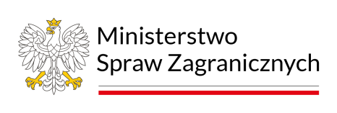
Supported with the funds of by the Ministry of Culture and National Heritage of the Republic of Poland as part of the ‘Word Power: Polish-Ukrainian literary dialogues’.

The Warsaw International Book Fair 2024 will be held at the Palace of Culture and Science and at Plac Defilad on June 23-26, 2024 presenting Italy as the Guest of Honour.

bookfairwarsaw.pl
