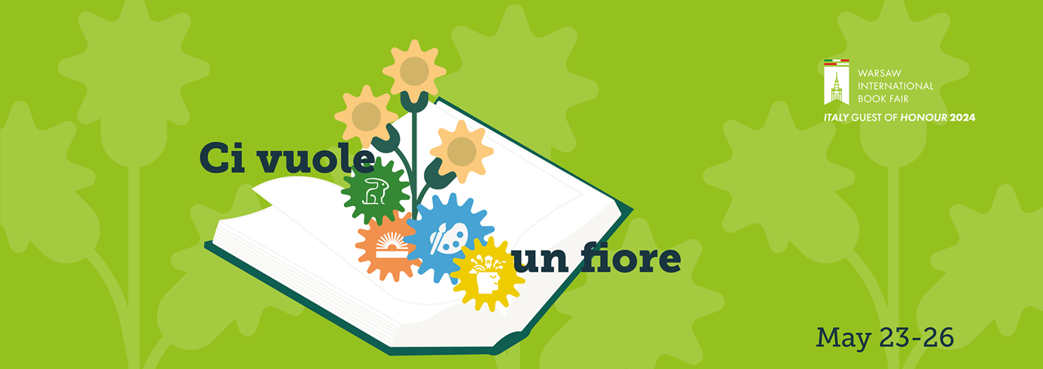

“Ci vuole un fiore”
Celebrating Italian Literature:
Italy is the Guest of Honour
during the 2024 Warsaw International Book Fair
Italy is a birthplace of European civilisation, culture and art; a place known for its flavours, style, design and motor industry. Above all, it is a country of fabulous literature and book illustrations. During the 2024 Warsaw International Book Fair, organized on May 23-26 at the Palace of Culture and Science and the adjacent Plac Defilad, Italy takes the spotlight as the Guest of Honour. The Italian programme, with the motto "Ci vuole un fiore" (“It takes a flower”), offers ample opportunity to explore the richness of contemporary Italian literature and meet Italian authors and publishers.
“Italy will be at the center of this year edition, with a rich series of events: more than 20 meetings, including lectures, conversations and round table discussions, which will give the Polish public the opportunity to meet some of the most acclaimed Italian contemporary writers, along with some emerging voices. It will be an extraordinary chance to learn about the richness and diversity of our literary culture and to promote it.”, says H.E. Luca Franchetti Pardo, Italian Ambassador to Warsaw.
“Furthermore, thanks to the events featuring publishing houses, workers in the sector and agents, the Fair will be a great opportunity for the Italian publishing industry to present its offer to a market of 40 million people who have a deep and genuine interest, nearly a thirst, for Italian culture in all of its forms. Poland is the third country in the world for acquisition of translations rights of Italian works: a significant number which makes the publishing industry a leading sector in the trade exchange between Italy and Poland, not only in the cultural field, but also in the commercial one.
“The chosen slogan to represent the Italian participation in the Fair is “It takes a flower” (“Ci vuole un fiore”), based on the title of a famous Gianni Rodari’s poem, put to music by Sergio Endrigo: a sentence which summarizes the deep and inseparable relation between human being, natural environment and the planet. It is about topics that are bound to become a priority in the years to come, and that will require a total commitment for a sustainable and equitable development.”, Ambassador Franchetti Pardo concludes.
The Guest of Honour stand, hosting Italian publishers, authors and other literary and cultural icons, will be located in the Marble Hall (No. 133).
The Fair will be attended by twelve Italian publishing houses representing various segments of the publishing market: Mondadori Libri, Reggio Children – International Centre for the defence and promotion of the rights and potential of all children, EurArte Editions, Il Saggiatore, Lavieri Edizioni, San Paolo Edizioni Srl, Il Castoro, White Star, Erickson, Hoepli, Il Pozzo di Giacobbe and Gallucci Editore.
More than twenty authors will come to Warsaw. The rich and varied agenda of events dedicated to Italian culture and literature will include meetings with authors, literary debates, market discussions, and the all-favourite autograph sessions. Meetings with Italian authors (with translation into Polish) will be held at the Palace of Culture and Science in Goethe, Kiev and Kisielewski Halls, as well as on the Main Stage, Pavilion F, at Plac Defilad (in front of the Kinoteka).
The Italian programme at the Warsaw International Book Fair will be kicked off by Carlo Gallucci and Gaia Stock, who publish children’s literature, with a discussion inspired by “Ci vuole un fiore”.
During four days of the Fair, Warsaw will welcome Italian prose writers and poets, authors of children's books, philosophers, literary and religious studies scholars, historians, journalists, masters of illustration and translation. The list of literary stars and popular artists from Italy includes Pietro Luca Azzaro, Alessandro Baldacci, Luigi Ballerini, Alessandro Barbero, Massimo Borghesi, Alessandro Campi, Andrea Colamedici, Mattia Corrente, Carlo Gallucci, Maura Gancitano, Helena Janeczek, Federica Manzon, Michele Marchitto, Luigi Marinelli, Laura Pugno, Stefano Redaelli, Antonio Riccardi, Davide Rondoni, Gaia Stock and Matteo Strukul.
All those who want to learn more about Italian publishing market should attend the meeting with Bruno Giancarli (EN/PL), from the Research Department of the Italian Publishers Association, who will talk about Italian publishing world in facts and figures.
To see the detailed agenda of literary and market events with participation of Italian creators, and to learn more about guests from Italy, make sure to visit targiksiazkiwarszawa.pl (Guest of Honour tab).
In the lobby of Goethe Hall, the most beautiful book covers will be presented at the exhibition entitled “Italian stories. Italian fiction illustrated”. The exhibition aspires to showcase how Italian fiction is often entrusted to the interpretation of an illustrator – whether it be work of a writer who has already become a classic or a young promising author. The illustrators – Manuele Fior, Beppe Giacobbe, Andrea Serio, Mario Sughi and Elisa Talentino – are among the most beloved and inimitable contemporary cartoonists. They use a variety of techniques, from watercolour to digital painting, in a distinctive and recognizable style. The exhibition was created in collaboration with Associazione Flangini and is curated by Melania Gazzotti.
The Exhibitors' Evening on the inauguration day will feature “Discover Italy through Song” – a concert by ITALIA FOLKSONGS performed by Daniele Di Bonaventura Band'Union
& Ilaria Pilar Patassini, which is a moving musical journey through the true sounds of the “Bel Paese”. Traditional melodies and dialects will return in a new, elegant and fascinating arrangement, with a tinge of jazz and folk.
Italy's participation as a Guest of Honor country at the Warsaw International Book Fair is possible thanks to the following Italian institutions: the Ministry of Foreign Affairs and International Cooperation, the Ministry of Culture, the Foreign Trade Promotion Agency ICE-ITA, the Centre for Books and Reading, which promotes the cultural program in collaboration with AIE - Italian Publishers Association. In Poland the project has been coordinated by the Italian Embassy, the Italian Cultural Institute in Warsaw and the ICE-ITA Office in Warsaw.
The Warsaw International Book Fair is a leading publishing industry event in Poland. The organisers expect nearly 600 exhibitors and several hundred distinguished authors from Poland, Italy and thirteen other countries: Austria, China, France, Germany, Japan, Norway, Romania, Slovakia, South Korea, Spain, Ukraine and the UK, as well as Free Belarus, represented by independent authors and publishers.
There is a rich programme of attractions for literature lovers: festivals, thematic zones, and industry events, including: Warsaw of Comics Festival, Warsaw Crime Story Festival, the Non-Fiction Day with Ryszard Kapuściński Award, Intergenerational Festival of Children's Literature, "Science Encounters" exhibition and events, and the Salons of Ukrainian Publishers and Independent Belarus Publishers.
The winners of prestigious prizes and awards will be announced during the Fair: ICARUS Award, presented by the Polish Society of Book Publishers and Warsaw International Book Fair; the 64th (2024) edition of the competition for Most Beautiful Books of the Year, organized by the Polish Society of Book Publishers; the 15th edition of Ryszard Kapuściński Award; Magellan Award for the Best Travel Publications; the Grand Prix of Warsaw Crime Story Festival; ACADEMIA Award for the best academic and scientific book; the 2023 awards of the Polish Librarians’ Association: Champion of Reading Promotion, Librarian of the Year, the Adam Łysakowski Scientific Award and Orient Men Award presented by the comic book community in Poland.
Visitors may enjoy events on two stages, in six halls, and, for the first time, in Rotunda building at the junction of Jerozolimskie and Marszałkowska, where Warsaw of Comics Festival will present some of its attractions, inter alia. The publishers invite visitors to pavilions and stands, where book authors can be spotted for a meet and greet and asked for an autograph. There will be social media streaming of selected events.
The Warsaw International Book Fair is organized by the History and Culture Foundation. Admission is free.
Opening hours:
23 May 2024: from 10 am to 6 pm
24 May 2024: from 10 am to 7 pm
25 May 2024: from 10 am to 7 pm
26 May 2024: from 10 am to 5 pm
For more information, please visit: targiksiazkiwarszawa.pl | Facebook | Instagram
Contacts:
The Warsaw International Book Fair
Natalia Zalewska-Domitrz
natalia.zalewska@historiaikultura.pl, +48 607 373 135
Italy – Guest of Honour
Miriam Peluffo
miriam.peluffo@esteri.it

