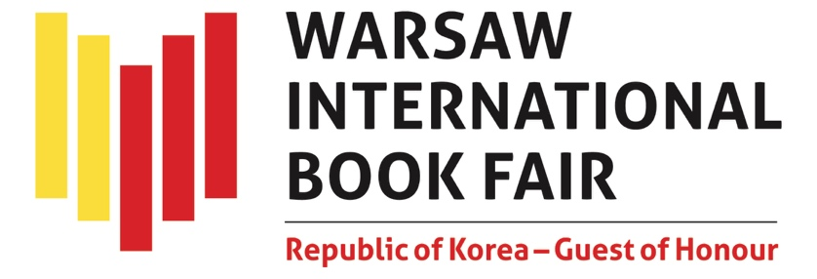

On May 15-18, the 2025 Warsaw International Book Fair is open to visitors at the Palace of Culture and Science, the Museum of Modern Art, and the nearby Parade Sq. This is the biggest literary event of the year in Poland, hosting more than 600 exhibitors and many outstanding creators from Poland and 19 countries, including the Republic of Korea, Bulgaria, China, Croatia, Czechia, France, Free Belarus (represented by independent Belarusian authors and publishers), Germany, Italy, Lithuania, Norway, Pakistan, the Philippines, Singapore, Spain, Turkey, Ukraine, the United Arab Emirates and the United Kingdom. A community of a thousand authors, translators, illustrators and other representatives of the publishing industry and the world of culture will attend. Events will be held on three stages and in seven halls, introducing the Museum of Modern Art as one of the venues. Readers can look forward to meeting their favourite authors at publishers' stands.
There is free admission for all visitors; selected events will be streamed on social media. Warsaw International Book Fair is organised by the History and Culture Foundation and Projekt Książka.

Bridging Worlds Through Words
The rich and varied programme of the Republic of Korea, the Guest of Honour, inspired by the motto “Bridging Worlds Through Words”, offers is a unique opportunity to explore contemporary Korean literature, culture and art, and discover how much we have in common.
Visitors will appreciate a chance to meet and greet true literary icons; the authors who are well-known and much-loved in Korea and beyond. The following authors will attend to present and sign their bestsellers and new publications: PARK Sangyoung, CHUNG Bora, JEON Heyjin, KIM Boyoung, Dr Victor D. Cha, Prof. Ramon Pacheco Pardo, KIM Hoyeon, YEON Somin, SHIN Kyungsook and YUN Jungeun.
Korean literature and history will be discussed by historians, academics and translators. You do not want to miss a meeting with Prof. Ramon Pacheco Pardo and Dr Victor D. Cha (“Korea. A New History of South and North”) or a lecture by Prof. Ewa Rynarzewska (“The Triumph of Ideology, Friendship, and the Market: a Short Story about the Polish Translation of Korean Literature”). Justyna Najbar-Miller, a translator, will talk about “Greek Lessons”, the new novel by HAN Kang, the winner of the 2024 Nobel Prize in Literature. Dr CHOI Jeongin and Filip Danecki will unpack cultural differences expressed in the language of Korean-Polish translations. Dr LEE Seungik will present "Historical Experience: Where Korea and Poland Meet Despite the Distance". We also recommend a lecture by Dr YOU Changil on similarities and differences between Korean and Polish way of thinking, and a panel discussion with Prof. Ewa Rynarzewska, Prof. Anna Diniejko-Wąs, Prof. Justyna Najbar-Miller and Dr CHOI Jeongi ("Translators in Debate: On Korean Literature’s (Un)translatable Limits"). The youngest visitors will certainly enjoy “Magical fun with books: little feet and little fingers”, a children’s workshop designed by Filip Danecki.
Those who want to learn more about the official support program for Korean literary translations should attend a seminar organized by the Korean Literary Translation Institute (LTI Korea); they are also welcome to visit LTI Korea desk at the Korean stand. All those interested in starting a partnership with Korean publishers will appreciate the “2025 K-Book Market Warsaw”, a two-day B2B event organized by the Publication Industry Promotion Agency of Korea (KPIPA). Polish partners can look forward to meeting fifteen renowned Korean publishers representing diverse profiles: fiction, non-fiction, business and economics, history, philosophy, education, art, language learning materials, children and young adult books, picture books, web novels and webtoons – registration link.
The Korean pavilion, located in the Marble Hall (No. 135, the Palace of Culture), will host authors, experts, publishers and public officials representing the institutions responsible for international promotion of Koran literature, including the Korean Literary Translation Institute (LTI Korea), the Korean Manhwa Promotion Agency (약칭: KOMACON), and the Publication Industry Promotion Agency of Korea (KPIPA). The pavilion will feature an immersive exhibition symbolizing a literary bridge connecting Poland and Korea, built with quotes from Polish literature published in Korea and Korean literary works published in Poland; the Hunminjeongeum exhibition, dedicated to Hangul, Korean alphabet; a unique exhibition of Korean design, showcasing everyday products inspired by the alphabet; and a webtoon exhibition. Selected publications of Korean authors will be available for purchase in the Guest of Honour pavilion.
Korean programme would not be complete without artistic performance. The audience at the Exhibitors' Gala will enjoy a “New Pansori” concert, inspired by the fusion of Korean and Polish culture trends: JANG Seoyoon, a singer and composer, and Rafał Mazur, a renowned Polish musician, will be accompanied by artists from the two countries. Another proposition, "Lyric Echoes: Polish Poem, Korean Timbre", is a contemporary music concert inspired by Polish literature (composed by: LEE Sangjun, GIM Youshin; performed by: Hashtag Ensemble). On May 17 (Saturday), cooking shows and tasting of Korean cuisine organised in collaboration with Daesang Holdings will be held in pavilion No. 29 (the outdoor area in front of the Palace). There will be attractions in other venues as well, including Korean movie screenings in the evenings, scheduled at Muranów Cinema between May 15 and 18.
For a detailed agenda of literary, artistic and industry events organised by the Guest of Honour, complete with the bios of participating creators, experts and artists, please see the website in Republic of Korea – Guest of Honour section. The 2025 Warsaw International Book Fair Guest of Honour programme has been developed by the Embassy of the Republic of Korea and the Korean Cultural Centre in Poland.

Bella Italia: Italian literature close-up and personal
Promotion of literary work from Italy, who was the Guest of Honour a year ago, starts with a meeting with Prof. Giulio Tremonti, former Italian Minister of Economy and Finance, a lawyer, politician and parliamentarian, who will talk about his book entitled “War or Peace”. There will be an opportunity to meet Dacia Maraini, an outstanding author of fiction, poetry, theatre plays and non-fiction books and a researcher of the condition of women, whose work is known and appreciated in dozens of countries. Her book “Vita mia”, published in 2024, is a memoir of grim and painful years spent in a concentration camp in Japan presented against the backdrop of family hope, courage and loyalty. Sebastiano Giorgi, the editor-in-chief of a popular Polish-Italian magazine Gazzetta Italia, will promote “Corte Polacca”, his latest book, published by Austeria. Sandrone Dazieri, one of Italy's most acclaimed writers and screenwriters, author of “The Evil That Men Do” (published by Sonia Draga), will attend Warsaw Crime Story Festival. Italian literature will also be promoted by Scripta Maneant and Manuscriptum publishers, who organised a meeting on “The Work of Michelangelo: Discovering the Sistine Chapel”.
To visit the Italian pavilion, featuring books in Italian and selected publications in Polish translation, look for stand No. 105 at the Palace of Culture and Science. The Italian programme has been developed by the Italian Embassy in Warsaw, the Italian Cultural Institute in Warsaw, and the Italian Trade Agency (ITA). More

The Ukrainian Literary Salon and the WORDPOWER Festival
As in previous years, visitors can look forward to an impressive Ukrainian programme at the Warsaw International Book Fair. The Ukrainian Literary Salon (stand No. 136 in the Marmurowa Hall at the Palace of Culture and Science) will host 28 publishers and a large group of authors, culture managers and journalists – some of them well-known in Poland, others making a debut. What is it that makes Ukrainian graphic novels, malopis, so unique? What does contemporary Ukrainian poetry sound like? What is the power of children's literature written during wartime? Join us for live talks with Ukrainian authors: Ija Kiwa (a poetess), Julia Vus (an illustrator and co-author of a graphic novel), and Tania Stus (a children's literature writer and researcher). Parallel to the Ukrainian Literary Salon, a new edition of the WORDPOWER Festival will presents discussions on Ukrainian and Polish literature. Ija Kiwa and Marcin Gaczkowski will talk about disruptive change in the world and how it is reflected in the language of literature. Marichka Paplauskaite and Tomasz Szerszeń will discuss how literary reportage and essays explain the world hiding behind the newsfeed. Krzysztof Czyżewski and Olena Huseinova will talk about memory and poetry of Victoria Amelina and Maksym Kryvtsov. In a candid conversation about motherhood without rose-coloured spectacles, stereotypes and delusions upheld by the media, Karina Savaryna will present her novel “Not Pregnant”. Ukrainian literary events are organised by the Ukrainian Embassy in Poland, the Ukrainian Book Institute, and the History and Culture Foundation.
Free Belarus Salon of Independent Belarusian Publishers
Independent Belarusian publishers united under the banner of “Free Belarus” will also be present at the Fair. Thirteen publishing houses will participate in Free Belarus Salon of Independent Belarusian Publishers (stand No. 140 in the Marmurowa Hall at the Palace of Culture and Science). There will be meetings with Aliaksandr Karnaukh and Ewa Wieżnawiec, presentations of new titles, and book signing sessions.
The Science Encounters and ACADEMIA Competition
Welcome to the fourth edition of the Science Encounters, a project designed to promote publications of Polish universities and academic publishers through meetings and discussions with popularisers of various fields of science. Traditionally, the academic and scientific publishing sector will be located in the Palace of Culture and Science (Korczak and Mikołajska Halls). The Science Encounters agenda starts with a meeting on “The Ukrainian language in Poland: integration, identity and cultural continuity”, featuring Dr Paweł Lewczuk, who wrote a scholarly monograph on ‘Multilingualism of war migrants from Ukraine in Poland’. The author and the guests will discuss the evolution of linguistic behaviour and identity of Ukrainians who have found temporary refuge in Poland and the role of the Ukrainian language as a medium used to keep the ties with one’s culture and literary tradition; they will also ponder why a study of multilingualism of Ukrainian migrants is not a purely scholarly exercise but also a cultural and diplomatic endeavour. Siedlce University Publishing House will host a meeting with Prof. Malina Kaszuba, who will talk about her book “Putin's Empire”; and Jagiellonian University Press will present Dr Grzegorz Bryda, author of the book “Digital Qualitative Sociology”, and Dr Marek Troszyński in conversation on how artificial intelligence has affected academic work. The University of Silesia Press will host a meeting with Dr Patryk Oczko, who wrote a monograph on the famous Animated Film Studio from Bielsko-Biała (“Nie tylko dla dzieci. Studio Filmów Rysunkowych w Bielsku-Białej 1947-2021”). Invited by Warsaw University Press, Prof. Ewa Krogulec, a geologist and the Vice-Rector for Development of the University of Warsaw, and Associate Prof. Agata Dziewulska will debate on contemporary global problems such as drought, water management and energy security, seen through the lens of science and its challenges. Finally, the Publishing House of the University of Warmia and Mazury in Olsztyn offers a meeting with Prof. Bernadetta Darska, who wrote “Berlinowanie. Zapiski z doświadczania miasta” and “Czas reportażu. O tym, co działo się wokół gatunku po 2010 roku”, and with Dr Martyna Siudak (“Opowiem ci Warmię, opowiem Mazury. Praktykowanie reportażu”). The Science Encounters sector and events are organised by the History and Culture Foundation.
Traditionally, on the second day of the Fair, the academic and scientific publishers will announce the winners of the ACADEMIA Competition for the best academic and scientific publication. The competition aims is to recognise and promote those who publish the best academic and scientific publications in a traditional, printed book format. This is the 18th edition of the event, and the numbers have been record-high. The expert jury, chaired by Prof. Elżbieta Zybert, reviewed a staggering 189 publications from 71 publishers (the competition is one of the few where the awards go the publishers). Financial prizes and honourable mentions are awarded in three categories: the ACADEMIA Grand Prix, the Prize of the Rector of the University of Warsaw (for the best academic publication in the field of social sciences and humanities), and the Prize of the Rector of the Warsaw University of Technology (for the best academic publication in the field of technical and exact sciences). There is honorary patronage of His Magnificence Prof. Alojzy Z. Nowak, Rector of the University of Warsaw, and His Magnificence Prof. Krzysztof Zaremba, Rector of the Warsaw University of Technology. The ACADEMIA Grand Prix is sponsored by the Society of Authors ZAIKS. The competition is organised by the Warsaw University Press, the Warsaw University of Technology Press, and the History and Culture Foundation.
Book launches, new titles and meeting highlights
Warsaw International Book Fair is a great opportunity to meet and greet your favourite authors, buy their books, and get autographs. The following authors will wait for the fans on the stages, in the halls and at exhibitors' stands: Father Adam Boniecki, Jacek Antczak and Hanna Krall, Katarzyna Bonda, Wojciech Chmielarz, Jacek Cygan, Jakub Ćwiek, Katarzyna Grochola, Małgorzata Halber, Aneta Jadowska, Grzegorz Kasdepke and Joanna Rusinek, Rafał Kosik and Wit Szostak, Marek Krajewski, Jolanta Kwaśniewska, Marisa de Lempicka, Stanisław Łubieński, Jul Łyskawa, Marcin Mortka, Juliusz Machulski and Krzysztof Varga, Katarzyna Puzyńska, Michał Rusinek, Vincent V. Severski, Beata Słama, Ziemowit Szczerek, Szczepan Twardoch, Ewa Woydyłło, Jakub Żulczyk. A line-up of media and podcast personalities includes Tomasz Sianecki, Filip Cembala, Krzysztof Pyzia, Małgorzata Halber, Marta Markiewicz, Robert Rutkowski, Monika Sławecka, Artur Górski, Michał Wrzosek, Anita Werner and Michał Kołodziejczyk.
Foreign authors are also invited, including those from Colombia, Free Belarus, Italy, Spain, Norway, Ukraine, the United Kingdom and the United States, to mention but a few countries.
On May 16 (Friday), Lauren Roberts, an American writer of romantic fantasy novels for young adults, will take the stage. Her visit to Poland coincides with the Polish launch of “Fearless”, the third volume of the “Powerless” series. Also on Friday, the Museum of Modern Art will host a meeting organised by Cervantes Institute with Marta Carnicero Hernanz, a Catalan writer and author of “Matrioskas”. Marisa de Lempicka will present the album dedicated to the artwork of Tamara Łempicka, and Bédu (Bernard Dumont), a Belgian comic strip artist and script writer and author of comics for children, will visit Warsaw of Comics Festival.
There is a rich programme of attractions for literature lovers, festivals and industry events, including: Warsaw of Comics Festival, Warsaw Crime Story Festival, the Non-Fiction Day with Ryszard Kapuściński Memorial Award, “Ojce i dziatki” Intergenerational Festival of Children's Literature, and the last year’s debut - Literary InfluSpace, with panel discussions and debates with top book-media creators.
In addition, an AUTOGRAPH ZONE will be set up as part of the Young & New Adult Literature Festival, where books will be signed by authors of the youngest generation, including: Natalia Antczak, Joanna Balicka, Lena M. Bielska, Marta Bijan, FortunateEm, Natalia Fromuth, Emilia Jachimczyk, Aneta Jadowska, Julia Kubicka, Marta Łabęcka, Aleksandra Muraszka, Aleksandra Negrońska, Izabella Nowaczyk, Weronika Plota, Agata Polte, Julia Popiel, Ludka Skrzydlewska, Zuzanna Wólczyńska.
Warsaw Crime Story and Warsaw of Comics Festivals
If you love crime stories, you will not want to miss Warsaw Crime Story Festival, organised under the auspices of Warsaw International Book Fair and hosting distinguished authors of the genre, including: Katarzyna Bonda, Krzysztof Bochus, Wojciech Chmielarz, Sandrone Dazieri, Eugeniusz Dębski and Beata Dębska, Krzysztof Domaradzki, Mieczysław Gorzka, Izabela Janiszewska, Anna Kańtoch, Marta Kisiel, Piotr Kościelny, Marek Krajewski, Robert Małecki, Robert Michniewicz, Klaudia Muniak, Zbyszek Nowak, Agnieszka Peszek, Ewa Przydryga, Katarzyna Puzyńska, Maciej Siembieda, Małgorzata Oliwia Sobczak, Bartosz Szczygielski, Jarosław Szczyżowski, Michał Śmielak.
The winners of this year's Grand Prix of the Warsaw Crime Festival will be announced at the Gala Event on May 16 (Friday).
The Grand Prix is funded by the Society of Authors ZAIKS.
Warsaw of Comics Festival, with its own section in pavilions A and B, offers a selection of meetings and workshops with authors of the genre, as well as interesting exhibitions. On top of that, there is a separate programme for creators and publishers. Comic book fans will have the opportunity to take part in workshops, buy the latest publications, meet their favourite creators and receive autographed drawings. This year, the festival will host Bédu, Wojciech Birek, Otto Ich, Łukasz Godlewski, Hanne Dewachter and Frederik Hautin, Stanislas Mousse, Marzena Sowa, Miguelanxo Prado, Tobiasz Piątkowski, Marek Oleksicki, Wiesław Skupniewicz, Przemysław Kłosin, Michał Śledziński and Marcin Łuczak, Karel Osoha, Krzysztof Owedyk, Tomasz Lew Leśniak and Rafał Skarżycki, inter alia.
The festival is organised by the Polish Comics Association.
Attractions for children and young adults
The youngest visitors can look forward to many literary attractions. There will be new releases and classics of children's and young adult literature, as well as meetings with creators: writers, translators and illustrators. On Thursday and Friday, organised school groups are welcome to join workshops and meetings hosted by the Association of Literary Translators, the Committee on the Rights of the Child and the Modern Poland Foundation, inter alia.
There will be stage interviews with authors, including a meeting with Grzegorz Kasdepke and Joanna Rusinek, a meeting with Michał Rusinek, workshops with Mikołaj Marcel, a meeting with Boguś Janiszewski, Max Skorwider and Agnieszka Maik, a meeting with Jarek Westermark and Mateusz Grydlik, a meeting with Artur Gębka and Kuba Hajkus.
On Sunday, Sara, Wiktor, Julia and Andrzej Żyracki, authors of the popular series “Zaczarowany Świat Sary”, will sign their books in the Autograph Zone.
“Ojce i Dziatki” Intergenerational Festival of Children's Literature is a unique event that brings generations together through literature and art. During the weekend, visitors can choose from a line-up of exciting workshops and events, meeting their favourite children's authors and developing their creativity through various artistic activities. It is a chance to learn more about the creative process, ask questions about your favourite characters and discover what inspires writers to create unforgettable stories. Przemysław Liput and Małgorzata Ruszkowska will take fans on an extraordinary journey across Warsaw; Zofia Stanecka and Marianna Oklejak will spill the beans on how “Basia’” series first came about; Agata Garlińska and Filip Danecki will invite visitors to join in magical games with books; Tomasz Duszyński will follow in the footsteps of Zuza Wróbel on a family field game full of puzzles and adventures; a comic book workshop will be held by Berenika Kołomycka; thanks to Eliza Piotrowska, we will have a chance to make friends with Barbara the Capybara and learn how to take things easy; Marcin Szczygielski and Maria Strzelecka will talk about the mission pursued by Mo, a man created by animals; Róża Hajkuś will help us learn what is what and how things work in a human body; Magdalena Kiełbowicz will introduce us to the one-and-only Marcel, a wizard with unique magical duties and dreams; Kasia Minasowicz will run an art workshop entitled “Portrait of a House”; and maestro Józef Wilkoń will bring us closer to the magic of illustration in “Dwoje przyjaciół”.
Celebrating May 17 with Norway!
The Norwegian Constitution Day will be celebrated during the Fair. On this occasion, the Royal Norwegian Embassy in Warsaw in cooperation with NORLA (Norwegian Literature Abroad) have prepared many literary attractions for children, young adults and families. Constitution Day celebrations on May 17 (Saturday) will be inspired by literary culture of this unique country, with fascinating stories and linguistic fun facts. Bjørn Rørvik, Per Dybvik and Monika Steinholm will be there to meet the fans. There will also be visual art classes and art and theatre workshops. Visitors will learn why May 17 is so important for Norwegians, especially for children. The youngest visitors will be introduced to Norway, they will listen to stories about this joyful ocassion, see colourful children's parades, learn a few Norwegian words and find out what the King of Norway does on this special day. Make sure to join us on May 17 (Saturday), between 10 am and 6 pm, in pavilion “S” (outdoors, in front of Kinoteka Cinema).

The Non-Fiction Day
On Saturday, literary reportage afficionados will want to visit the Auditorium of the Museum of Modern Art to meet authors of the books shortlisted for the 16th edition of Ryszard Kapuściński Memorial Award, presented by the City Council of Warsaw and co-organised by Gazeta Wyborcza.
Patricia Nieto and Aleksandra Zbroja will present “Wybrani” (ArtRage); Maciej Pisuk and Arkadiusz Gruszczyński – “Staniemy się tacy jak on” (Cyranka); Andrzej Dybczak and Wojciech Szot – “Las duchów” (Nisza); Pablo Trincia and Paulina Reiter – “All the Lies They Did Not Tell. The True Story of Satanic Panic in an Italian Community” (Otwarte); Sam Knight and Emilia Dłużewska – “Biuro Przeczuć. Historia psychiatry, który chciał przewidzieć przyszłość” (Wydawnictwo Czarne).
“Practice of Love and Care”
This is the tagline of the programme developed by the Capital City of Warsaw. In the Warsaw Pavilion (“H”), visitors will find a selection of books that explore the theme of love and care from many different perspectives. Apart from great books, there will be workshops, meetings and art installations designed by those who believe that to love and to care is to be continuously engaged in educational and artistic practice, and sometimes to defend and fight for the rights. The books short-listed for the Literary Award of the Capital City of Warsaw and the Ryszard Kapuściński Memorial Award for Literary Reportage will also be available for purchase. Two free publications will be available at the Warsaw Pavilion: “Wszystko w moich rękach” by Joanna Synowiec, a book on the topic of motherhood; and “Stolica Literatury” city magazine.
The Fryderyk Chopin Institute: Chopin recitals and events
This is a once-in-five-years opportunity. In the year of the Chopin Competition, the greatest musical event in Poland and one of the most important musical events in the world, the NIFP plans to present the music of Fryderyk Chopin in several piano recitals; each one about fifteen minutes long. The recitals will take place in the Marble Hall inside the Palace of Culture and Science. The NIFC has also organised a series of events on the Open-Air Stage, including a discussion on how to get children interested in music with Kasia Walentynowicz and Marta Bacewicz, authors of a series of biographies of Polish composers for young readers; a meeting with Filip Dowjat about his photo book “Wdech”, documenting the 18th International Fryderyk Chopin Piano Competition; and a meeting with Piotr Mysłakowski on his research on Chopin's family and milieu.
Online catalogue of books
This year, our exhibitors were given the opportunity to select five titles from their portfolios and post them online in the official catalogue of the 2025 Warsaw International Book Fair. Make sure to visit www.targiksiazkiwarszawa.pl/katalog-online for an impressive collection of books that are worth showing off and worth reading – in brief, the best of the best!
The book market, or the events for industry professionals
Our industry guests can choose from more than twenty meetings, debates and workshops tailor-made for book publishers, translators, illustrators, booksellers, librarians and teachers. A wide range of important issues will be covered, including the UK model of the book market and whether it would be a good idea to copy it in Poland; the role of artificial intelligence in the publishing industry and in literary translation; children's books, but without stereotypes; the agenda and plans of the Literary Field Task Force operating under the auspices of the Ministry of Culture and National Heritage in Poland; the translator-editor cooperation; the theme of accessibility in publishing; a panel on the role of a publisher as the author’s agent; a discussion panel on the interdisciplinary dimension of reading promotion; the first Polish-German fellowship programme for publishers, organised by Frankfurt and Warsaw International Book Fairs; a panel on author-publisher relations; the position of bookshops in the local community; artificial intelligence and the revolution in the world of books; how AI is changing the book market; freedom of speech and beyond – a conversation with Belarusian publishers operating in Poland.
The following institutions are the Partners of the industry programme: Polish Chamber of Books, Polish Society of Book Publishers, Association of Polish Librarians, Association of Polish Booksellers, Association of Literary Translators, Polish Section of IBBY, the Night of Libraries, the Committee on the Rights of the Child, NielsenIQ BookData.
Prizes and awards
The winners of prestigious prizes and awards will be announced during the Fair:
- ICARUS Award, presented by the Warsaw International Book Fair and the Polish Society of Book Publishers; funded by the Society of Authors ZAIKS;
- The 65th edition of the competition for Most Beautiful Books of the Year;
- The 16th edition of the Ryszard Kapuściński Memorial Award;
- The Magellan Award for the Best Travel Publications;
- The Grand Prix of Warsaw Crime Story Festival, funded by the Society of Authors ZAIKS;
- „Nowa Fantastyka” awards;
- The ACADEMIA Awards for the best academic and scientific book, with the Grand Prix funded by the Society of Authors ZAIKS.
The Warsaw International Book Fair is a leading publishing industry event in Poland.
Opening hours:
15 May 2025: between 10 am and 6 pm
16 May 2025: between 10 am and 7 pm
17 May 2025: between 10 am and 7 pm
18 May 2025: between 10 am and 5 pm
For more information, please visit: targiksiazkiwarszawa.pl | Facebook | Instagram

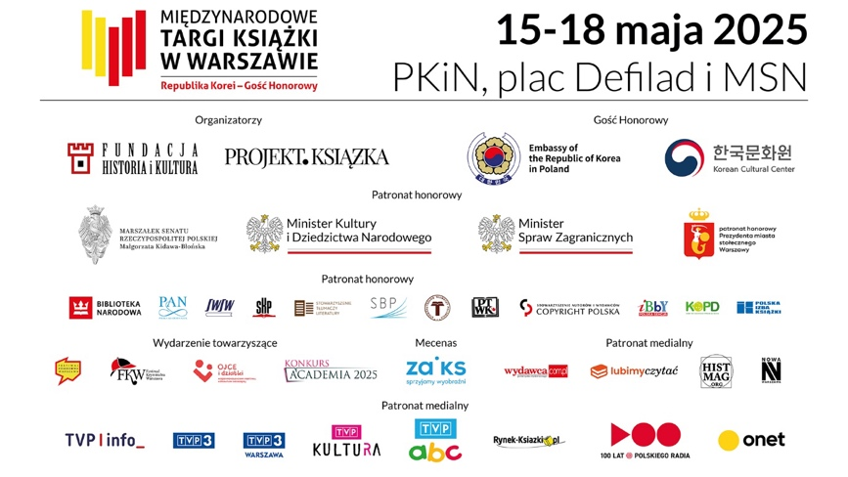
Spotkania z Nauką
The Science Encounters
Financed from public resources allocated by Polish Minister of Education and Science: “Social Responsibility of Science II – Popularization of Science” programme.
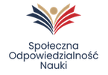
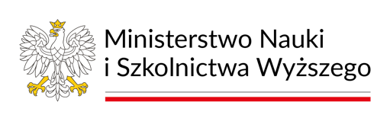

Festiwal SIŁA SŁOWA
The WORDPOWER Festival
Supported by the Polish Minister of Culture and National Heritage; the Culture Promotion Fund.
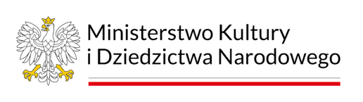

Ukraiński Salon Książki
The Ukrainian Literary Salon
Supported by the Mieroszewski Centre; the 3rd Open Call.
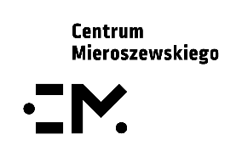

Salon Niezależnych Białoruskich Wydawców „Wolna Białoruś”
The Free Belarus Salon of Independent Belarusian Publishers]
Supported by the Mieroszewski Centre; the 3rd Open Call.

