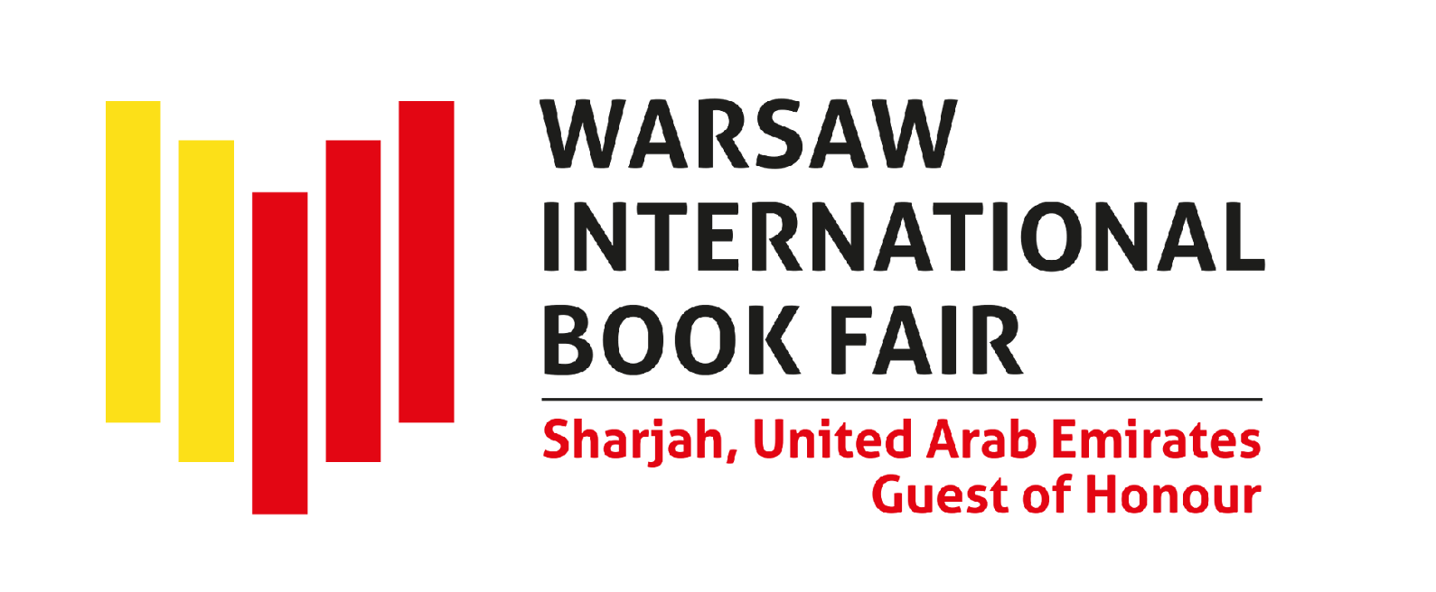

Sharjah Named Guest of Honour
at the 2026 Warsaw International Book Fair
The 2026 Warsaw International Book Fair, scheduled for May 28–31, is going to be held at a new venue: the PGE Narodowy Stadium. The Guest of Honour is the Emirate of Sharjah. The agreement confirming Sharjah’s presence as the Guest of Honour at the Warsaw International Book Fair was signed during the Sharjah International Book Fair on 13 November 2025. The Guest of Honour programme at the Warsaw International Book Fair is organised by the Sharjah Book Authority (SBA).
“Sharjah’s presence as Guest of Honour in Warsaw marks an exciting new chapter in our cultural journey, extending the bridges we have built across Europe to Central and Eastern Europe for the first time. Under the guidance of His Highness Sheikh Dr Sultan bin Mohammed Al Qasimi, Supreme Council Member and Ruler of Sharjah, our Emirate has long believed in culture as a force for connection and understanding. Poland’s own history reflects a centuries-old relationship with Arab and Muslim civilisations. Through this participation, we are honoured to bring to Warsaw the depth and diversity of Emirati and Arab literature, art, cuisine, and creativity, celebrating the shared human values that unite our cultures”, said Her Highness Sheikha Bodour bint Sultan Al Qasimi, Chairperson of the Sharjah Book Authority (SBA), organiser of the Guest of Honour programme.
While announcing the first details of Sharjah’s participation in next year’s Warsaw International Book Fair, the organisers emphasise that “this honour underscores the UAE’s cultural prominence, strengthens ties with Poland and the global community, and celebrates the Sharjah Book Authority’s (SBA) enduring commitment to fostering literature, empowering publishers, and preserving the region’s rich heritage. For Poland and international audiences, Sharjah’s participation offers a vibrant showcase of Arab and Emirati literary and intellectual traditions, rooted in its legacy as a UNESCO World Book Capital. Through initiatives like the Guest of Honour programme, Sharjah continues to enrich the global cultural landscape by harnessing the power of the written word.
As Guest of Honour, Sharjah aims to highlight its deep-rooted cultural heritage and dynamic contemporary literary and publishing scene; introduce Polish and global audiences to diverse Arab and Emirati voices; foster meaningful cross-cultural dialogue among writers, thinkers, and publishers; strengthen cultural and professional ties between the UAE, Poland, and Europe; and celebrate books as a universal force for building tolerant, interconnected societies. Visitors from Poland and beyond are invited to join the Sharjah pavilion in 2026 to immerse themselves in stories, engage with authors, explore publishing expertise, and experience heritage through a rich programme of discussions, performances, and cultural encounters — creating an unforgettable chapter at the Warsaw International Book Fair that forges new bonds of friendship and shared knowledge”, encourage the organisers of Sharjah's presentation at the fair in Warsaw.
“In recent years, cooperation between Poland and the UAE – and especially with the emirates that are deeply committed to promoting culture, such as Sharjah – has taken on a new, inspiring dimension. Sharjah's presence in Warsaw, while being a celebration of literature, will also give impetus to establishing lasting relationships between authors, publishers, agents and readers from the two countries. We are delighted to welcome Sharjah as Guest of Honour at the 2026 Warsaw International Book Fair. We are confident that this literary event will help bring our cultures and communities together, serving as a symbolic bridge for authors, publishers and readers, with the onset of many valuable initiatives that will give us a better understanding of the richness of the UAE's culture and heritage and Sharjah’s creative energy. We can hardly wait to learn about the traditions and hear the stories that Sharjah is going to bring to Warsaw for this fascinating literary journey”, said Jacek Oryl, Warsaw International Book Fair Director.
The Warsaw International Book Fair is organised by the History and Culture Foundation and Projekt KSIĄŻKA Ltd.

The Warsaw International Book Fair
Social media: Facebook | Instagram | YouTube
Publisher registration: https://targi-ksiazki-warszawa26.exposupport.pl/Login

Sharjah, United Arab Emirates – Guest of Honour
The Sharjah Book Authority (SBA)

